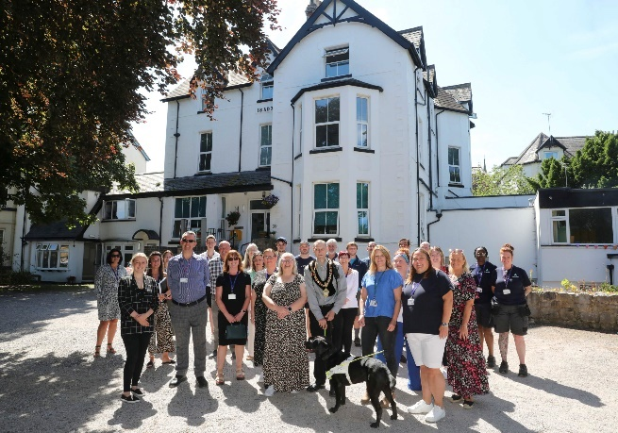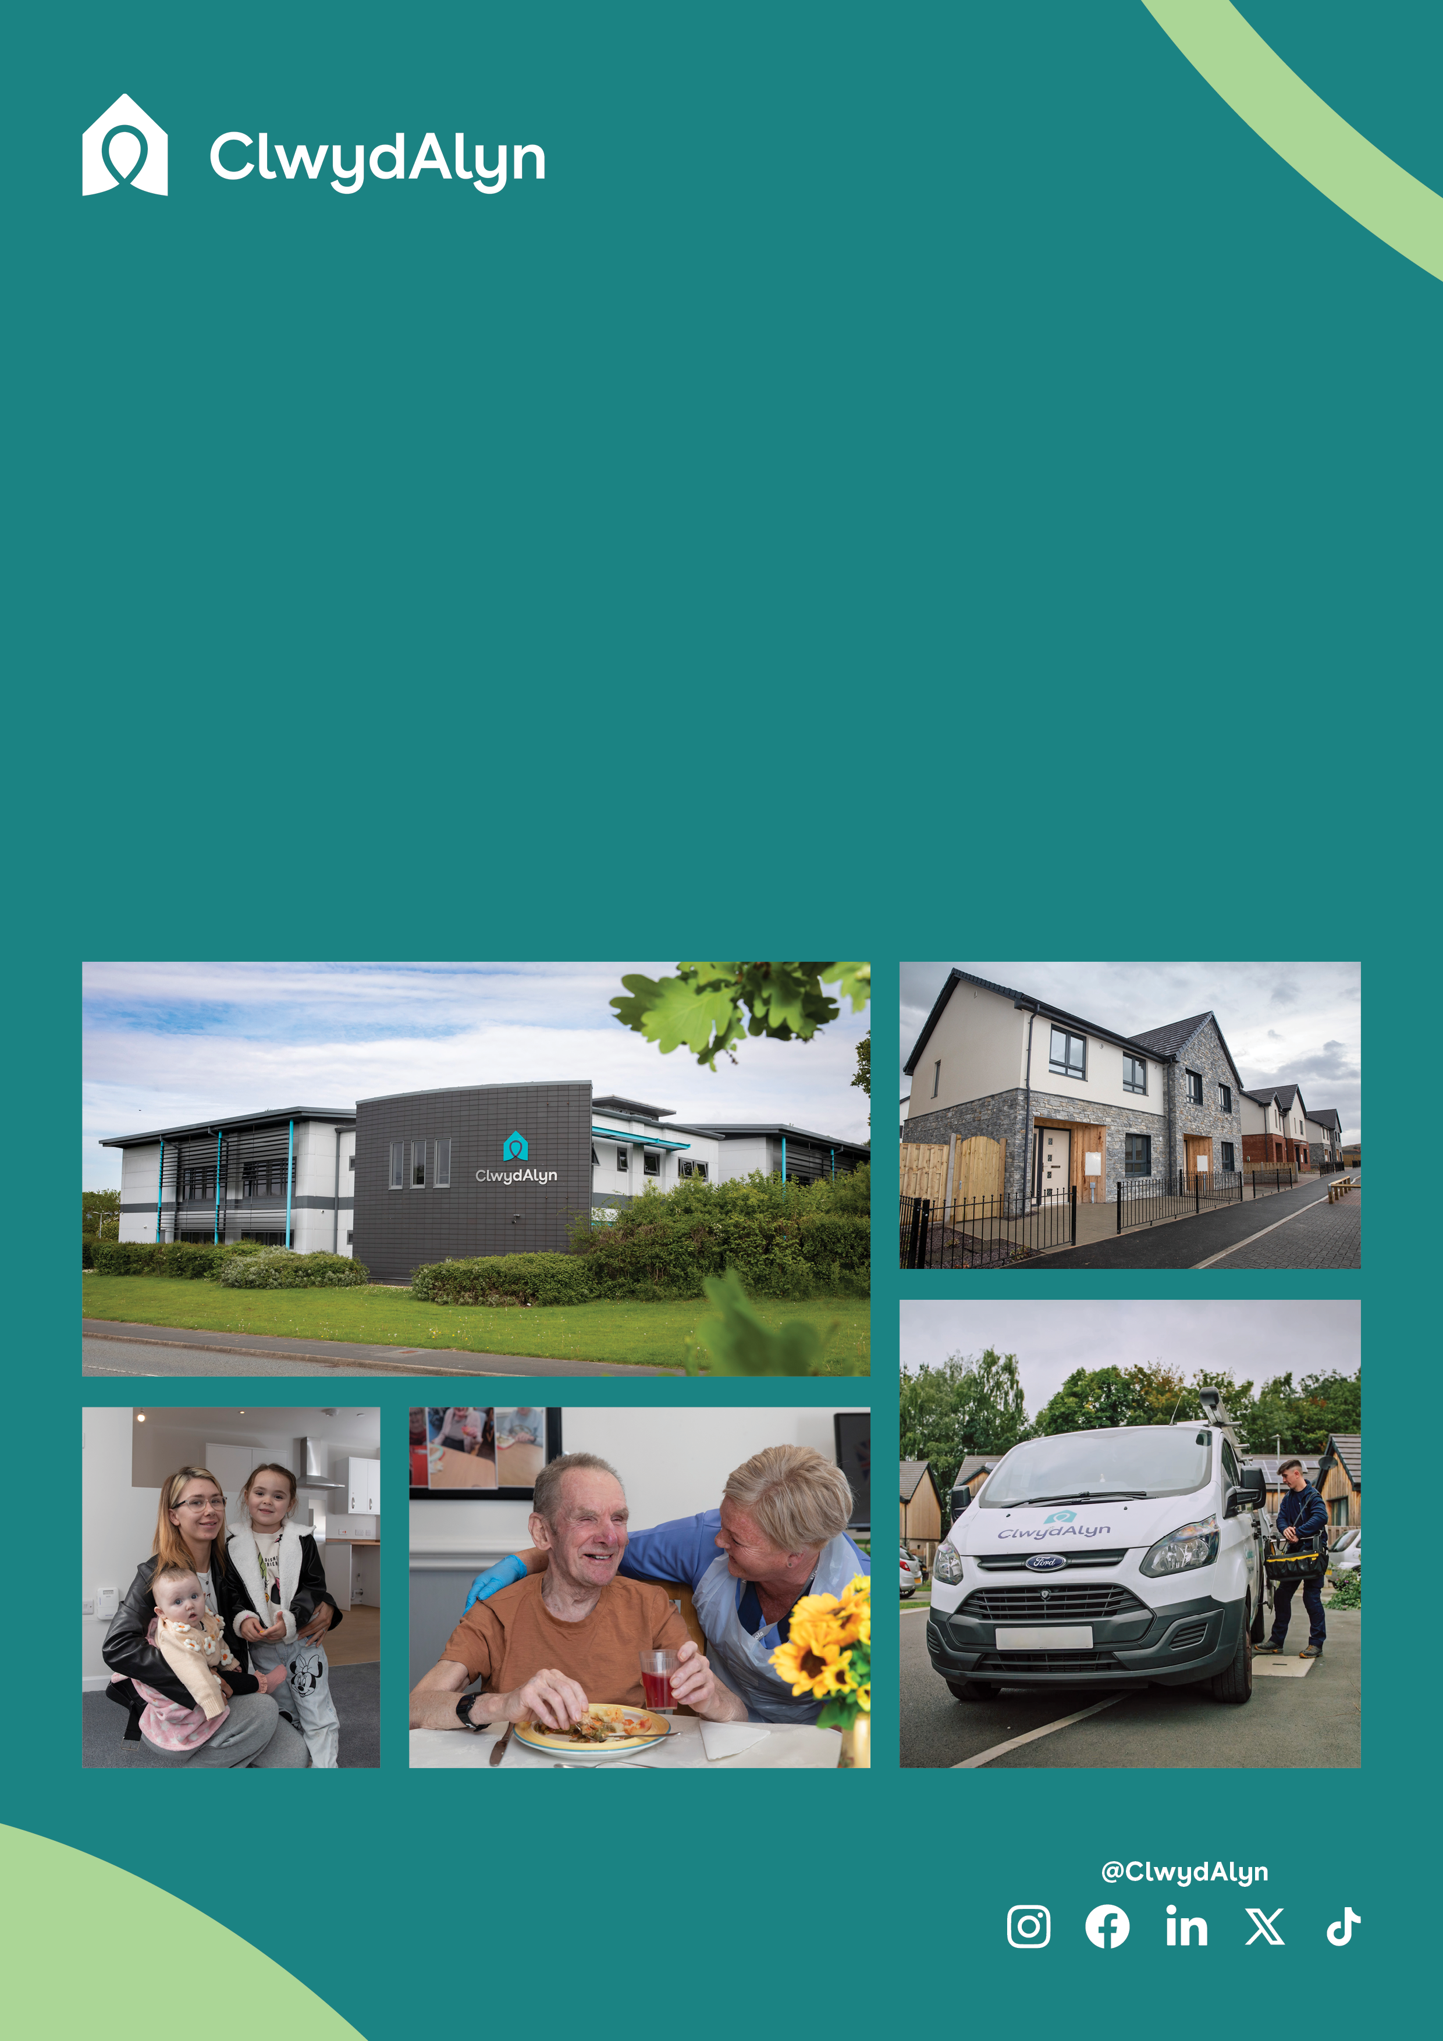

# *Job Overview*

# Scheme Concierge – Days & Nights

# Permanent & Part time available.

*Department:* ***Supported Living***

* Pay: £12.00 per hour
* Located: Colwyn Bay
* Hours: Two Night Shifts @ 37 hours a week
  + One Day Shift at 24 hours a week

What is a Scheme Concierge at ClwydAlyn

A Concierge plays a vital role in our supported living communities. If you're passionate about helping others and creating an environment where residents can flourish, this might be the perfect role for you. Our mission at ClwydAlyn is “Together to Beat Poverty!” As a Concierge on either days or nights, you will play a key role in helping us eradicate the causes of poverty across North Wales by enhancing the lives and promoting the wellbeing of our residents.

**Key Responsibilities:**

* **First Point of Contact:** You'll be the welcoming face for residents, controlling access to and from the building, ensuring everyone's safety.
* **Support and Guidance:** Your role involves providing support and guidance to residents, helping them make positive choices and encouraging their personal growth. This could lead to volunteering, apprenticeships, work placements, education, and eventually, an independent lifestyle.
* **Record Keeping:** Accurately recording and capturing necessary information is a key part of your job.
* **Teamwork**: Working closely with the team, you'll embody our values, ensuring safeguarding, health, and safety are at the forefront of everything you do.
* **Open and Honest Conversations:** You'll need to be bold and confident, ready to have honest conversations and provide constructive feedback.
* **Resilience:** Dealing with challenging behaviours with a resilient and patient approach is crucial.

**Qualities We Look For:**

* **Inclusivity and Support:** We value inclusivity and are passionate about giving people support in their homes and communities to improve their quality of life.
* **Leading by Example:** Demonstrating our values, behaviours, and Code of Conduct is expected.
* **Accountability:** Taking responsibility for your actions and those of the team.
* **Respect:** Treating everyone as an individual and being open to change.
* **Collaboration:** Working with partner agencies to find solutions to the challenges we face.

**Are You a Good Fit?**

**One of the key questions to ask yourself is: "Are you okay with people making bad choices?**

**This role is not about imposing your views and values on how to live but about supporting residents, even when they make choices you might not agree with.**

If you have relevant experience in dealing with people or front-of-house duties, and you’re looking for a challenging but rewarding job that makes a real difference in people's lives, we’d love to hear from you.

# *Job Overview*

# Night Concierge

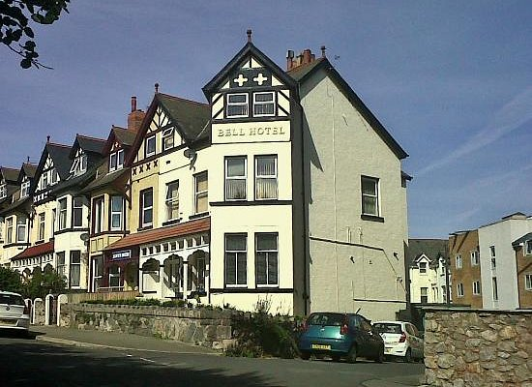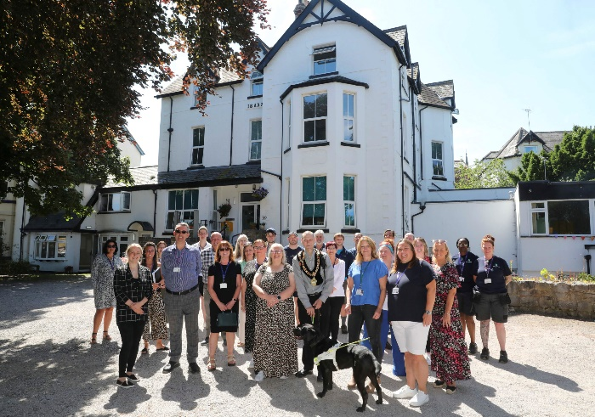

# *Job Overview* Scheme Concierge – Days & Nights

# 

**About the schemes you will be working in.**

**Norfolk House**

Norfolk House is a supported living scheme located in a welcoming and supportive community, Norfolk House provides a safe and nurturing environment for residents who need assistance in their daily lives.

We believe that everyone deserves the opportunity to live a fulfilling and independent life. Norfolk House plays a vital role in this mission by offering residents the support they need to improve their quality of life, build their confidence, and work towards greater independence.

**Who Lives at Norfolk House?** Norfolk House is home to a diverse group of residents, each with unique needs and backgrounds. Many of our residents are overcoming challenges such as homelessness, substance misuse, or mental health issues. We provide them with a stable and supportive environment where they can rebuild their lives and work towards their goals.

**The Bell**

The Bell is a supported living scheme that provides accommodation and support for six young homeless individuals. This scheme is part of ClwydAlyn's broader mission to assist vulnerable populations by offering a safe and supportive environment where residents can work on overcoming the issues that led to their homelessness. Help is offered to help residents develop the skills necessary to maintain their own homes and achieve greater independence in the future.

**What to expect.**

Both schemes offer extensive training and support. ClwydAlyn has a dedicated Learning and Development department focused on helping you grow and progress in your career. The organisation operates on values of kindness, hope, and trust, ensuring that all team members work in an environment that promotes personal and professional development. This commitment to training and support ensures that you will have the resources and guidance needed to succeed in your role and make a meaningful impact in the lives of the residents.

OUR VACANCIES

A: x2 Full time Night Concierge: 37 hours per week, £12.00 per hour

B: 1 Day Concierge: 24 hours per week, £12.00 per hour

# *Job Overview* Night Concierge

# 

You can What’s app your CV, Audio note or Video by using the number 07881837177

You’re welcome to contact us for an informal chat call 0800 1835757 or email [recruitmentca@clwydalyn.co.uk](mailto:recruitmentca@clwydalyn.co.uk)

Come have a conversation with us, we look forward to hearing from you!

When you apply, please make sure in your cover letter / application you specify which role you are applying for

A: Night Concierge, - 37 hours

B. Day Concierge – 24 hours

# How to apply?