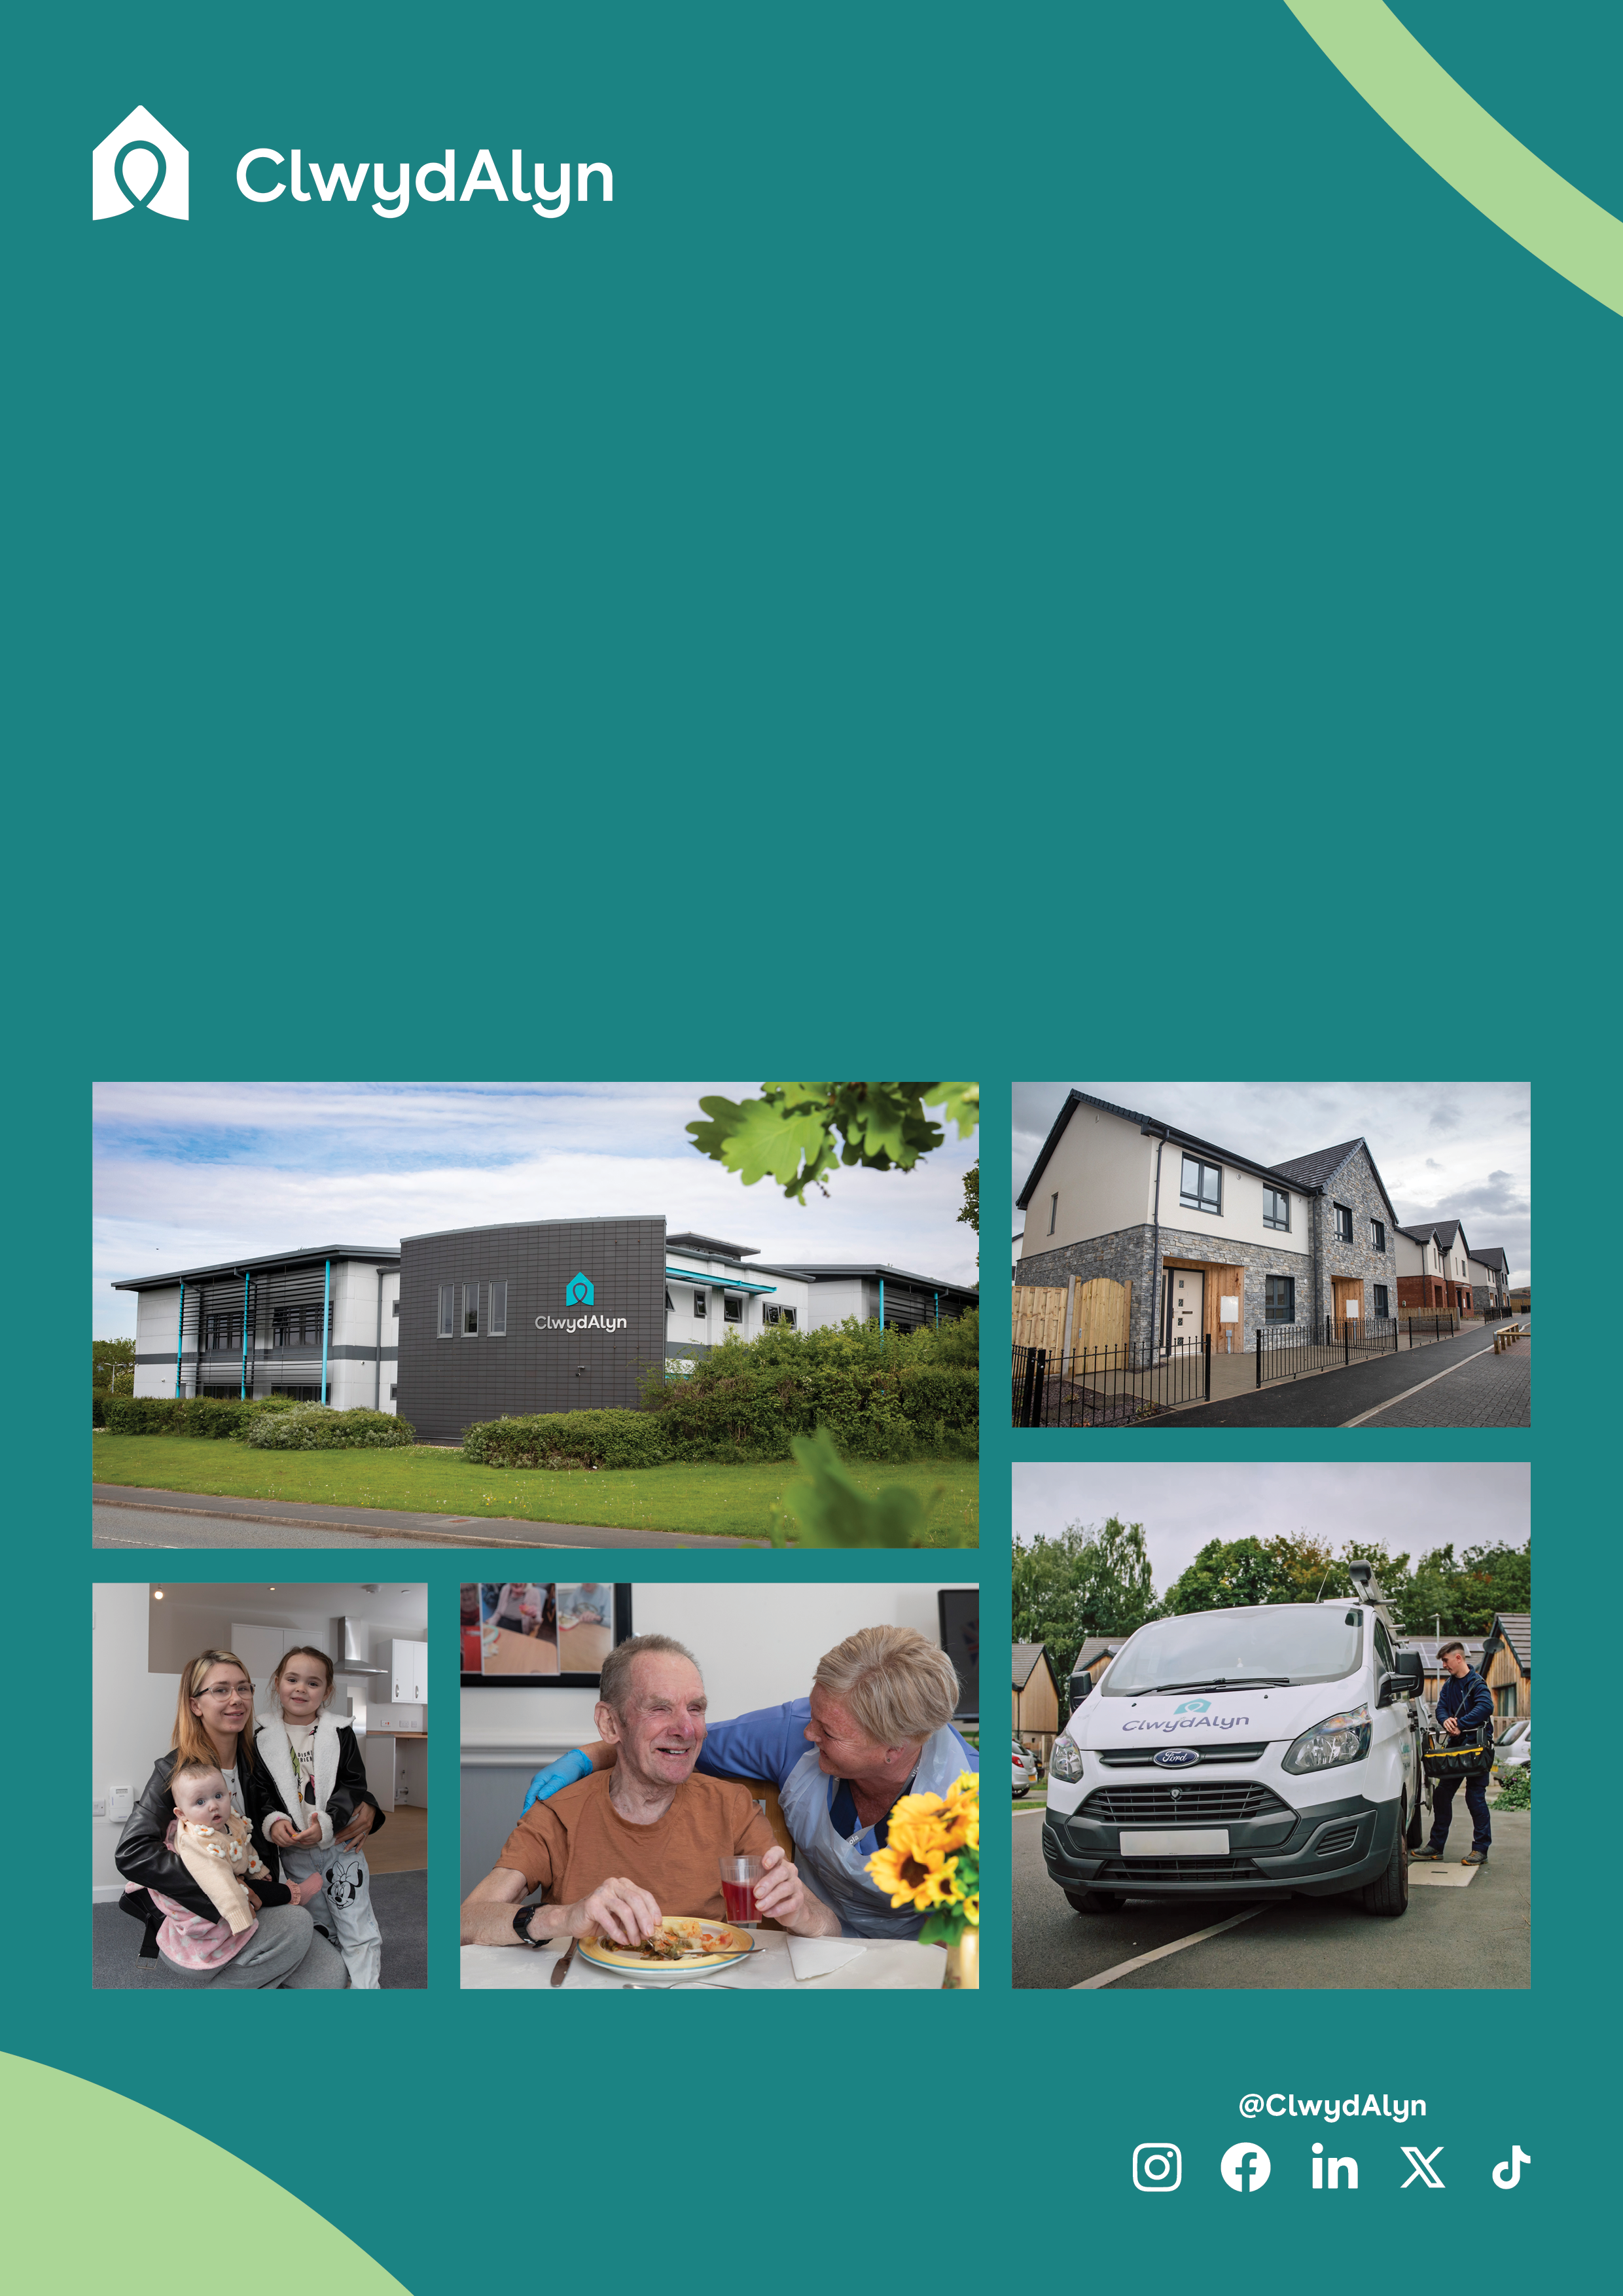

* Pay: £12.00 per hour
* Located: Welshpool, **Neuadd Maldwyn**
* 26 hours a week

# *Job Overview*

# Domestic Cleaner

# Permanent

*Department:* ***Supported Living***

**Department:** Resident Support Services

**Salary** **£12 per hour**

**Location:** Welshpool

* **Hours:** 1 26 hours a week - Weekdays and some weekends

**Job purpose:** As a Domestic Cleaner at **Neuadd Maldwyn**, your primary responsibility is to maintain a high standard of cleanliness throughout the care home. This includes cleaning resident rooms, communal areas, and staff facilities to ensure a hygienic and comfortable environment.

You will need to be able be mindful of equipment and materials the team uses and use your computer skills to reorder / replenish required materials when required.

**Qualifications:** This role requires an Enhanced Disclosure & Barring Service (DBS) check, which we pay for

**Is this role right for you?**

# The role of a Domestic Cleaner at Neuadd Maldwyn Care Home in Welshpool is ideal if you are detail-oriented, reliable, and professional. You should have a strong work ethic and be physically capable of handling cleaning tasks. Compassion and empathy are essential, as your work directly impacts the well-being of our residents.

# Being a team player who can collaborate with colleagues and adapt to a dynamic environment will help you thrive in this role. If these qualities describe you, we encourage you to apply and make a meaningful difference in our residents' lives.

# *Job Overview*

# Domestic Cleaner

# Key Responsibilities and Core Roles

# Provide Cleaning Services: Ensure all designated areas of the care home are clean and hygienic.

# Laundry Services: Manage efficient and effective laundry services for residents.

# Supply Management: Order and maintain cleaning supplies for the scheme.

# Maintain Clean and Safe Environment: Keep the living environment clean and safe to an acceptable standard.

# Health & Safety Awareness: Be alert to any health and safety issues that may arise and take appropriate action.

# COSHH Knowledge: Have a good working knowledge of the Control of Substances Hazardous to Health Regulations (COSHH).

# Collaboration: Work alongside residents and staff to support a clean and safe living environment.

# *Job Overview* Domestic Cleaner

# 

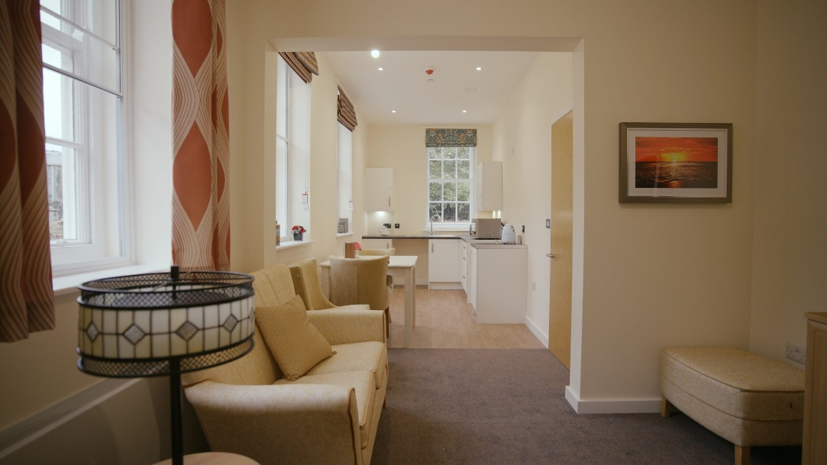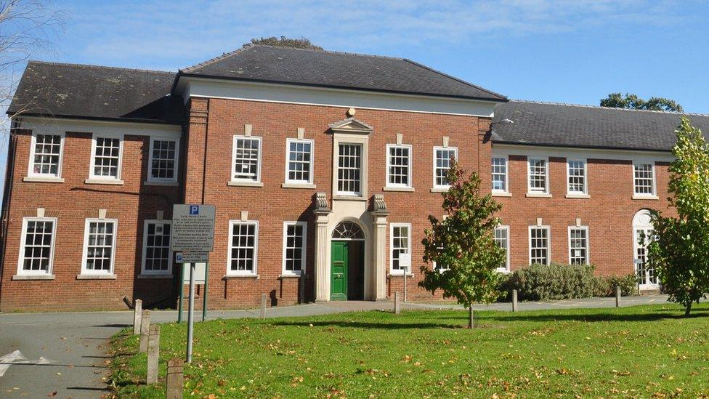\

**Neuadd Maldwyn Care Home**

Neuadd Maldwyn Care Home is a newly developed facility located in the heart of Welshpool. Housed in a historic Neo-Georgian Grade II listed building, this care home has been transformed into 66 high-quality apartments for rent, designed specifically for individuals aged 60 and over who have assessed care or support needs. Our residents are older adults who require various levels of care and support.

They come from diverse backgrounds and have unique needs that we strive to meet with compassion and professionalism. The goal is to provide a comfortable, safe, and engaging environment where residents can enjoy a high quality of life. With local amenities and transport links just a short walk away, Neuadd Maldwyn is the perfect place to live and work.

# *Job Overview* Domestic Cleaner

As well as a free meal every day for all staff, other benefits include:

Good luck!

You can What’s app your CV, Audio note or Video by using the number 07881837177

 or email [recruitmentca@clwydalyn.co.uk](mailto:recruitmentca@clwydalyn.co.uk)

You can also apply online by visiting our website www.clwydalyn.co.uk/work-for-us

Come have a conversation with us, we look forward to hearing from you!

# How to apply?