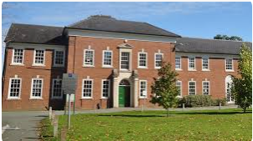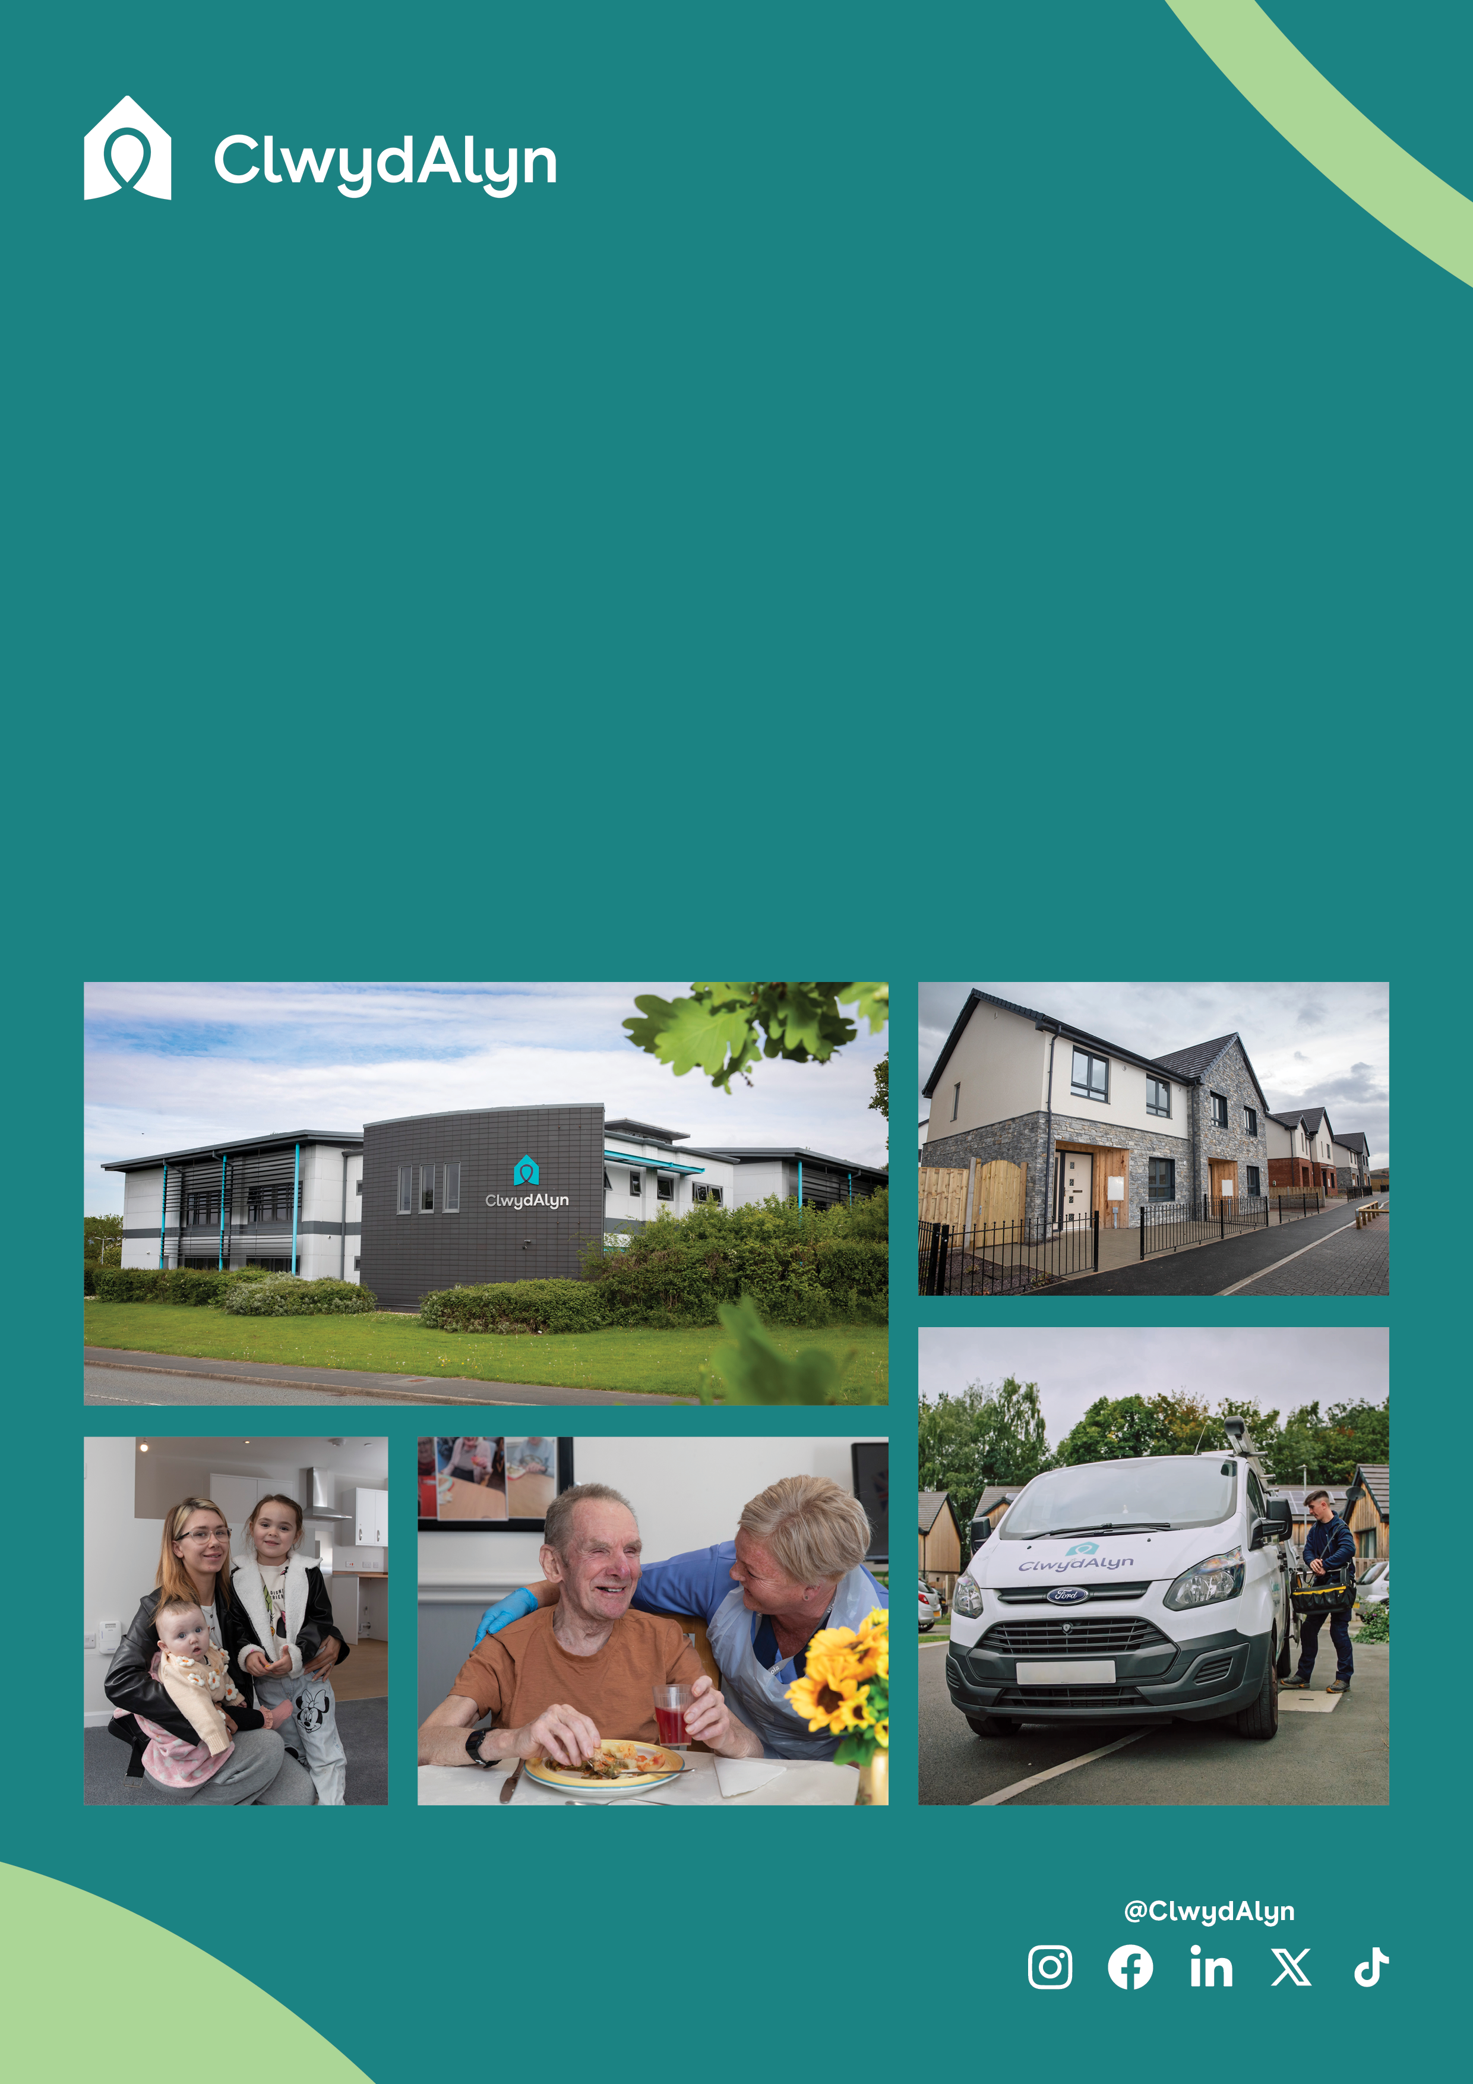

* Pay: £12.40 per hour
* Located: Welshpool, **Neuadd Maldwyn**
* Hours: 1 vacancy @ 24 hours a week

# *Job Overview*

Cook

# Permanent

*Department:* ***Supported Living***

**Is this role right for you?**

# The role of Cook at Neuadd Maldwyn is ideal if you have a passion for food, enjoy working as part of a team, and are committed to delivering high-quality meals to residents. To thrive in this role, you should have a solid understanding of food hygiene and preparation practices, either through prior experience or relevant qualifications. You will need to be reliable, hardworking, and adaptable, with the ability to handle various tasks in a busy kitchen environment.

# A positive attitude, attention to detail, and strong communication skills are essential, as you will be leading and supporting a team to create enjoyable and nutritious meals for our residents. Additionally, you should resonate with our core values of Trust, Hope, and Kindness, ensuring that every interaction and task reflects these principles. If you're motivated by making a difference and advancing your career in a supportive, friendly environment, this role could be the perfect opportunity for you.

# *Job Overview*

Cook

**Department:** Resident Support Services

**Salary** **£12.40 per hour**

**Location:** Welshpool

* **Hours:** 24 hours a week

**Job purpose:** The purpose of this role at Neuadd Maldwyn, a brand-new Extra Care home in Welshpool, is to support the Chef/Cook in Charge and the scheme manager by implementing effective kitchen operations. This includes providing nutritious meals to residents, supervising kitchen staff, and ensuring the kitchen is well-stocked and compliant with all health and hygiene regulations.

The successful candidate will have a significant impact on residents' well-being by preparing meals that cater to their dietary needs and preferences, maintaining cleanliness, and adhering to food safety standards. Working at Neuadd Maldwyn offers the opportunity to be part of a dedicated team in a state-of-the-art facility, ensuring high-quality care and support for residents

**Qualifications:** This role requires an Enhanced Disclosure & Barring Service (DBS) check, which we pay for

# Key Responsibilities and Core Functions

# Meal Preparation: Prepare and cook nutritious meals for residents, ensuring dietary requirements and preferences are met.

# Compliance: Adhere to all health, hygiene, and food safety regulations, including allergen laws and Safer Food Better Business requirements.

# Inventory Management: Assist in ordering food supplies, receiving deliveries, and ensuring proper storage and stock rotation.

# Cleanliness: Maintain cleanliness of the kitchen, work areas, and equipment, conducting regular checks and reporting any defects.

# Special Diets: Be knowledgeable about and capable of preparing food for residents with special dietary needs.

# Documentation: Complete necessary documentation to comply with environmental health and safety standards.

# Waste Management: Work with the Cook in Charge/Head Chef to minimize food wastage by understanding and reporting residents' food preferences and dietary requirements.

# Reporting: Report to the Cook in Charge/Head Chef, ensuring smooth communication and effective kitchen operations.

*Job Overview*  
Cook

# 

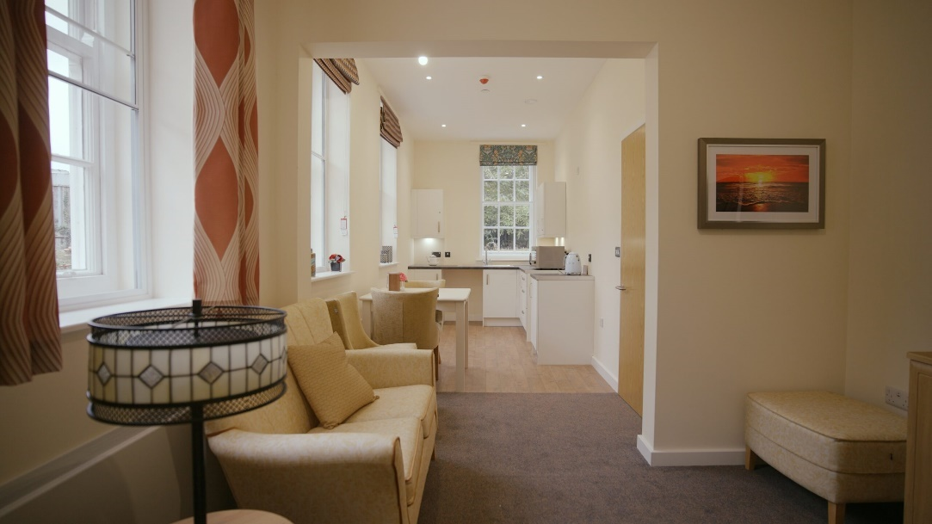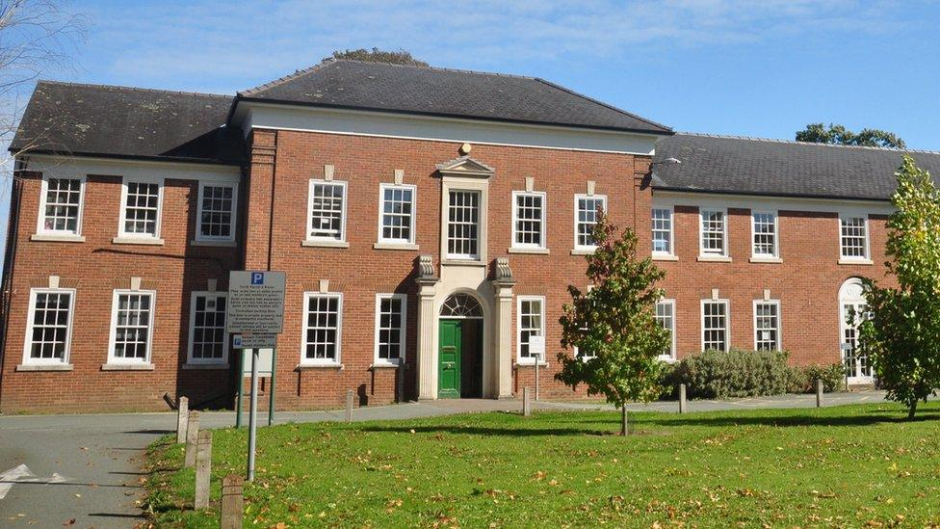\

# *Job Overview* Neuadd Maldwyn

# 

**Neuadd Maldwyn Care Home**

Neuadd Maldwyn Care Home is a newly developed facility located in the heart of Welshpool. Housed in a historic Neo-Georgian Grade II listed building, this care home has been transformed into 66 high-quality apartments for rent, designed specifically for individuals aged 60 and over who have assessed care or support needs. Our residents are older adults who require various levels of care and support.

They come from diverse backgrounds and have unique needs that we strive to meet with compassion and professionalism. The goal is to provide a comfortable, safe, and engaging environment where residents can enjoy a high quality of life. With local amenities and transport links just a short walk away, Neuadd Maldwyn is the perfect place to live and work.

As well as a free meal every day for all staff, other benefits include:

Good luck!

You can What’s app your CV, Audio note or Video by using the number 07881837177

 or email [recruitmentca@clwydalyn.co.uk](mailto:recruitmentca@clwydalyn.co.uk)

You can also apply online by visiting our website www.clwydalyn.co.uk/work-for-us

Come have a conversation with us, we look forward to hearing from you!

# How to apply?