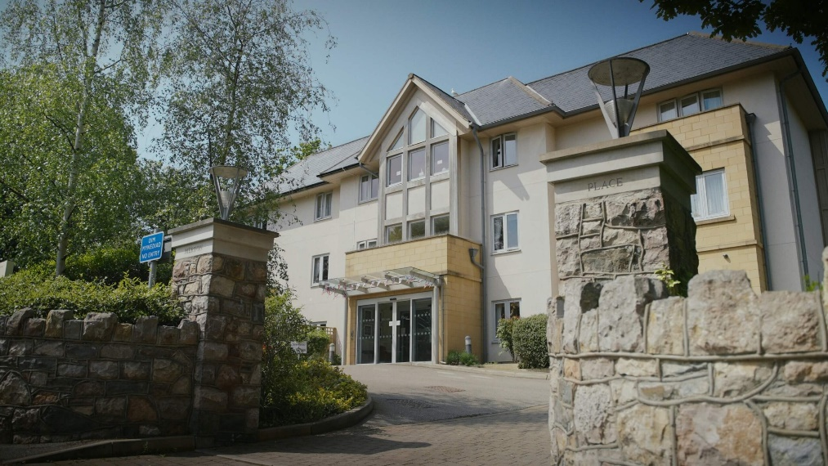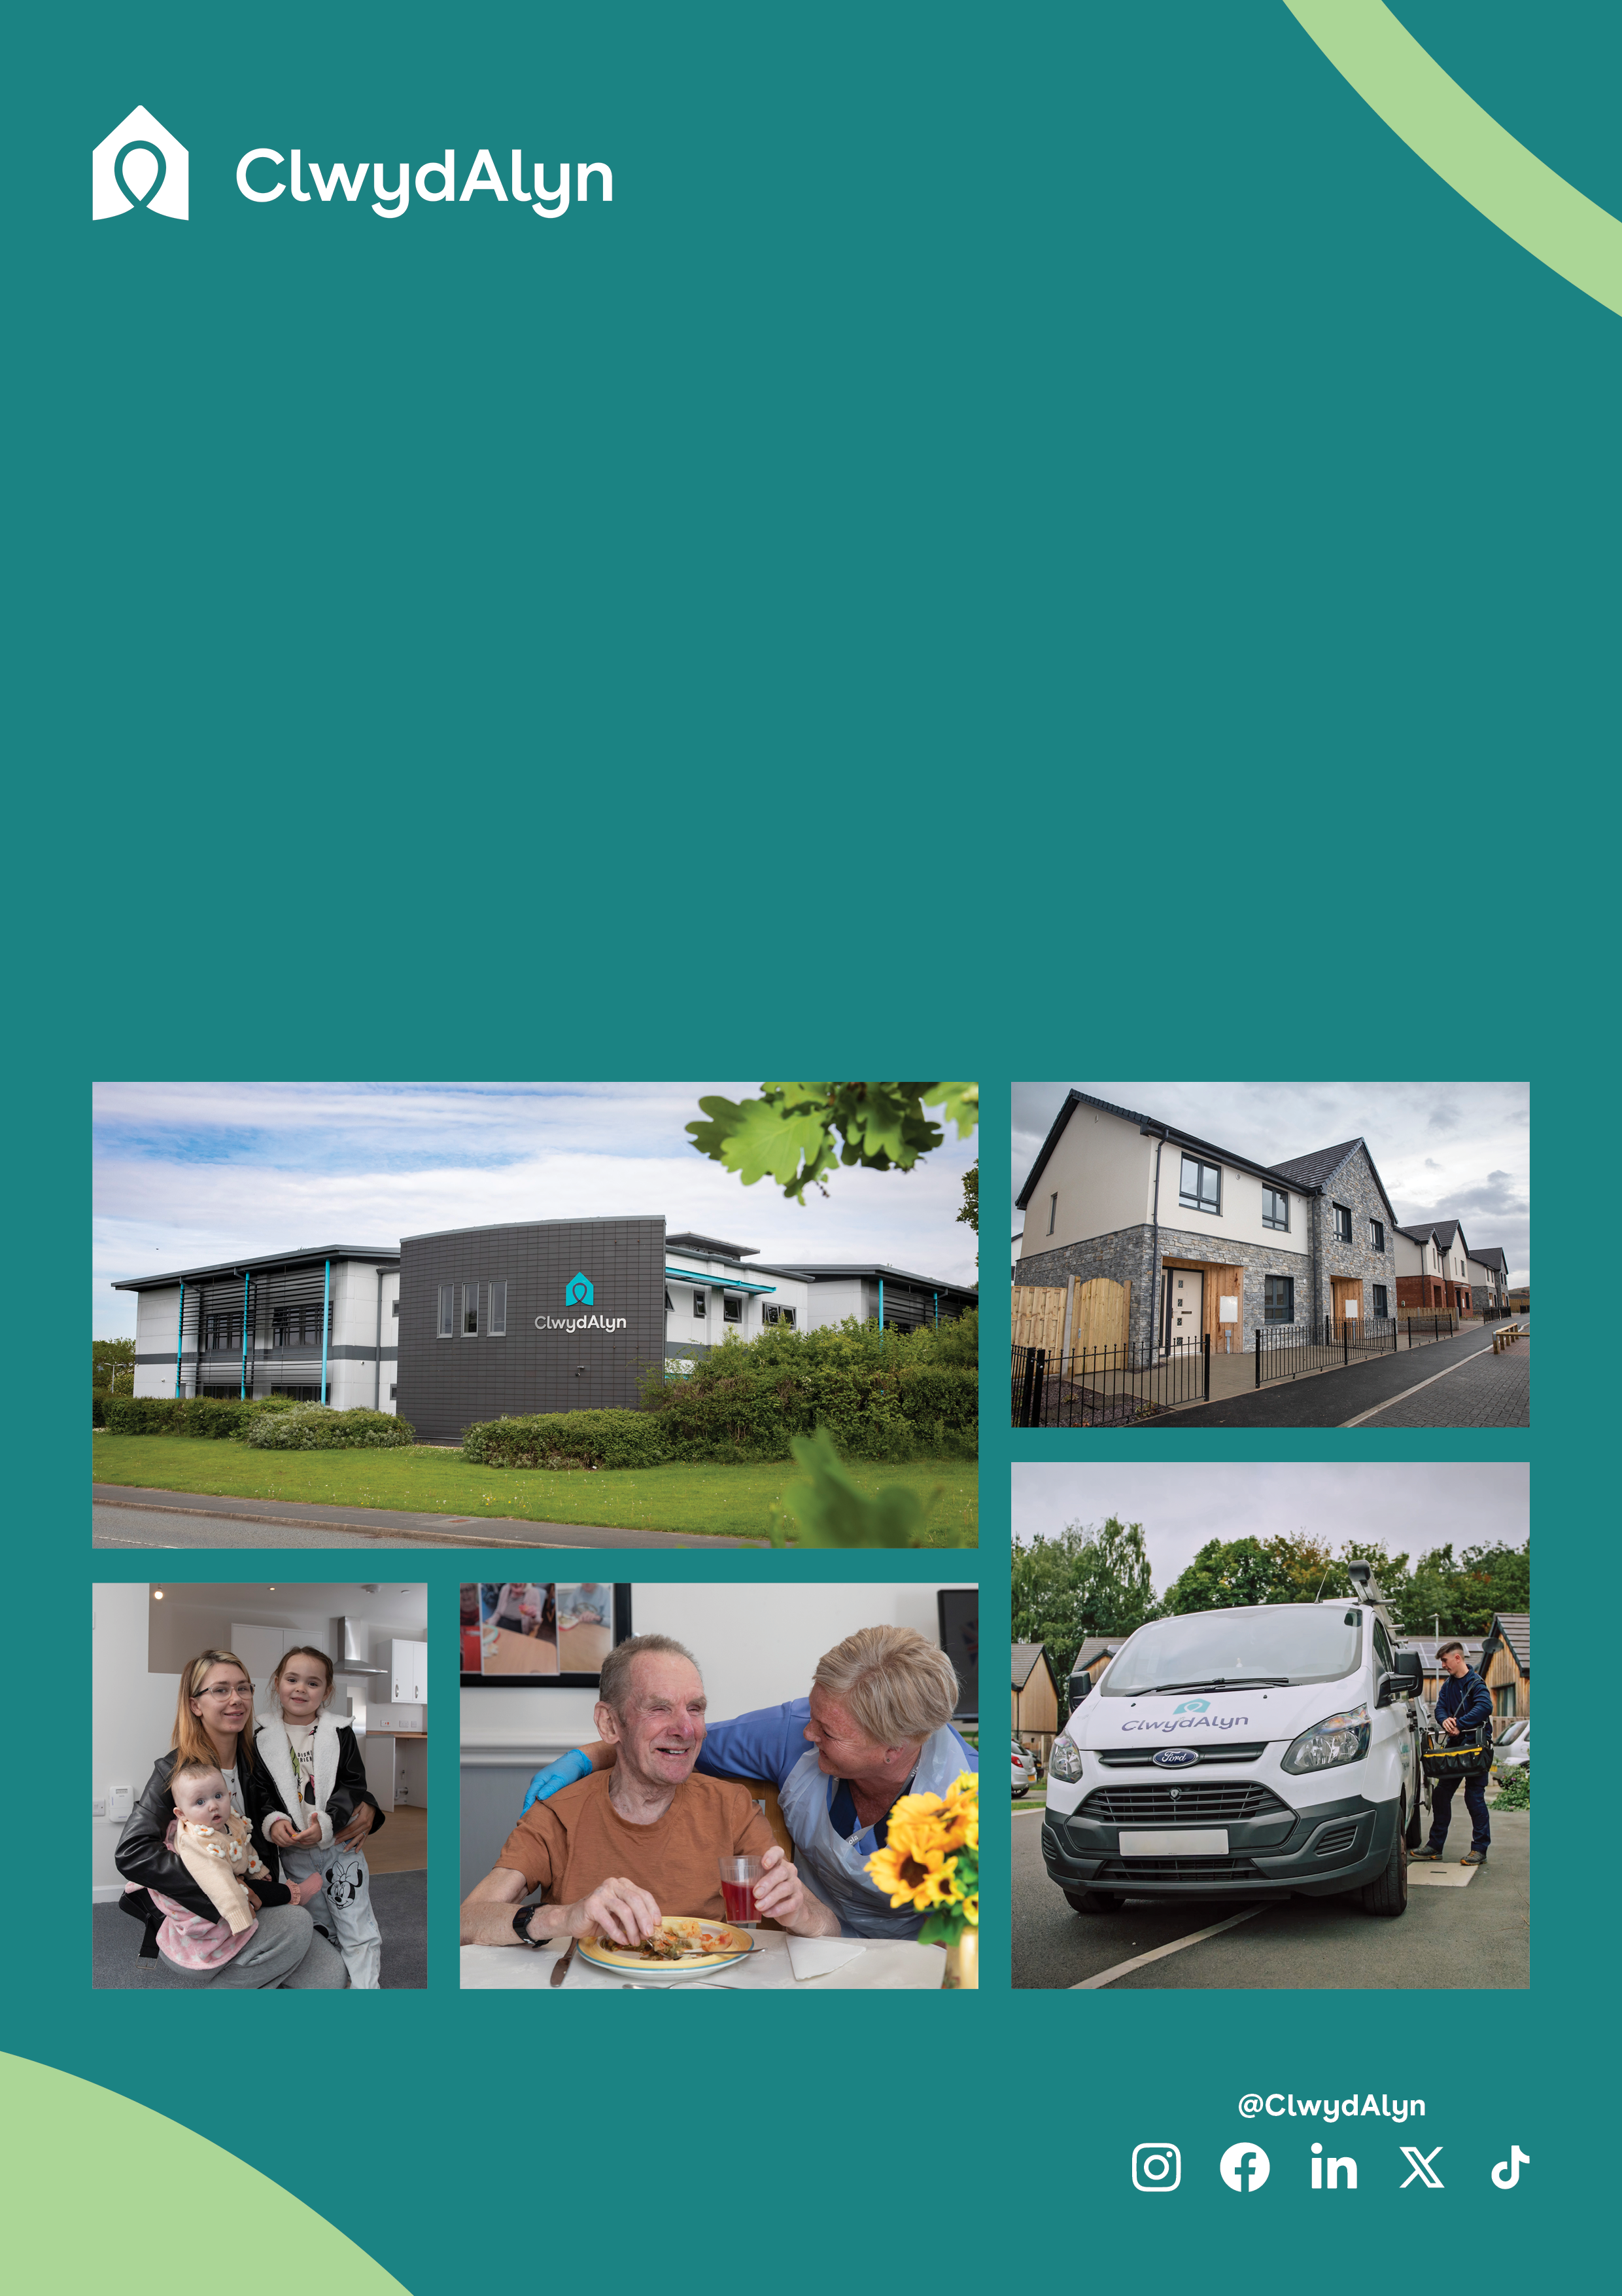

# *Job Overview*

# Cook In Charge

# Permanent

*Department:* ***Care Home***

* Pay: £13.36 per hour
* Located: Colwyn Bay
* Hours: 36 hours a week

# As a dedicated team member at ClwydAlyn’s Merton Place Care Home, you'll play a crucial role in enhancing the lives of our residents. At ClwydAlyn, we champion values of trust, hope, and kindness, fostering a supportive and appreciative environment for all team members.

# Your responsibilities at Merton Place extend beyond daily tasks; you'll ensure our residents receive exceptional care tailored to their individual needs. Whether you're managing operations, providing direct care, or supporting the team, your efforts will contribute to a culture of excellence and compassion.

# Joining ClwydAlyn at Merton Place means being part of a community that prioritizes professional growth, teamwork, and the wellbeing of both employees and residents. Your commitment will help us sustain a nurturing and thriving environment where trust, hope, and kindness are the cornerstones of our mission.

# *Job Overview*

# Cook in Charge

**Department:** Catering

**Salary** **£13.36 per hour**

**Location:** Colwyn Bay – Merton Place

**Hours:** 36 hours a week

**Job purpose:** As the Cook in Charge at ClwydAlyn, you will oversee the daily kitchen. Your role includes managing the kitchen team, ensuring all food preparation meets dietary needs and special requirements, and adhering to health and hygiene regulations. You will also handle food orders, stock rotation, and ensure the cleanliness and safety of the kitchen environment, playing a key part in creating a supportive and healthy living environment for our residents

**Qualifications:** Level 2 Food Hygiene, Allergen Awareness certificate, Catering Qualification, or relevant extensive catering experience.

# *Job Overview* Cook in Charge

# 

**Key responsibilities**

**Daily Kitchen Operations Management**

Oversee the preparation and delivery of nutritious meals, ensuring all dietary requirements and special requests are met.

**Staff Supervision and Training**

Direct and supervise kitchen assistants, ensuring adequate staff coverage and adherence to best practices in food preparation and hygiene.

**Health and Safety Compliance**

Implement and adhere to all health and hygiene regulations, including allergen laws and food safety standards. Ensure the kitchen and equipment are clean and maintained, conducting daily checks and inspections.

**Inventory and Supply Management**

Manage food orders, receive deliveries, ensure proper storage, and maintain stock rotation to minimize waste and ensure the kitchen is well stocked with fresh supplies.

**Documentation and Record Keeping**

Maintain all required documentation to meet Safer Food Better Business standards and Environmental Health requirements. Use internal systems to track records and report any near misses or incidents.

**Resident Engagement and Service Flexibility**

Be responsive to the needs of the residents, accommodating special dietary requests and preferences. Ensure food is delivered to resident accommodations when needed, enhancing their overall dining experience.

Why work for us – Benefits

As well as a free meal every day for all staff, other benefits include:

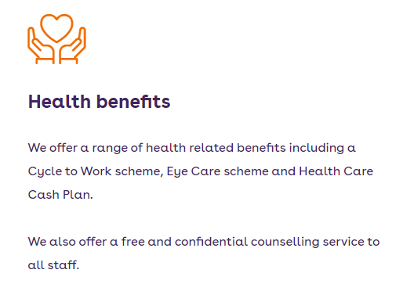

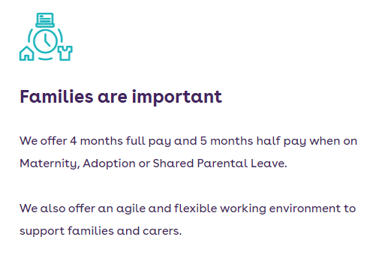

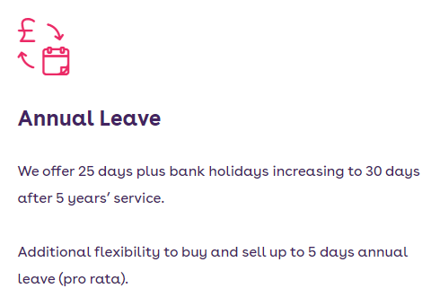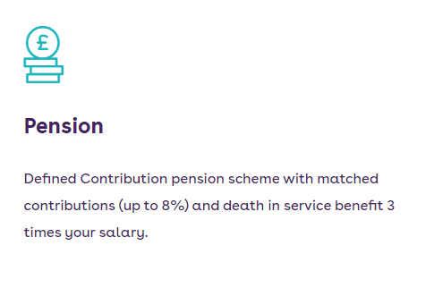

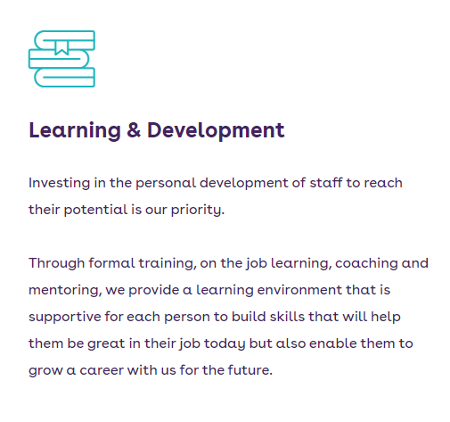

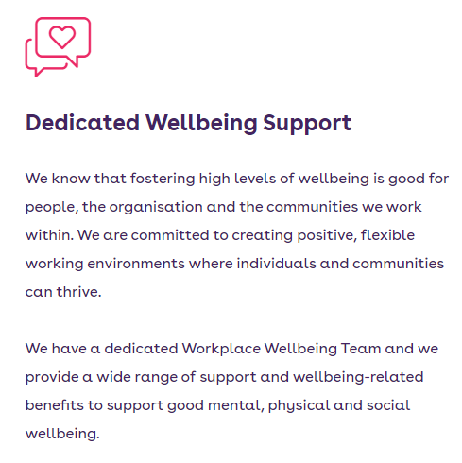

You can What’s app your CV, Audio note or Video by using the number 07881837177

You’re welcome to contact us for an informal chat call [01492 523375](https://www.google.com/search?q=merton+place+colwyn+bay+phone+number)

or email [recruitmentca@clwydalyn.co.uk](mailto:recruitmentca@clwydalyn.co.uk)

Come have a conversation with us, we look forward to hearing from you!

# How to apply?

Good luck!