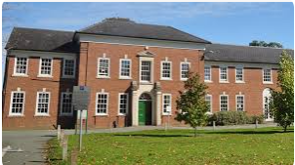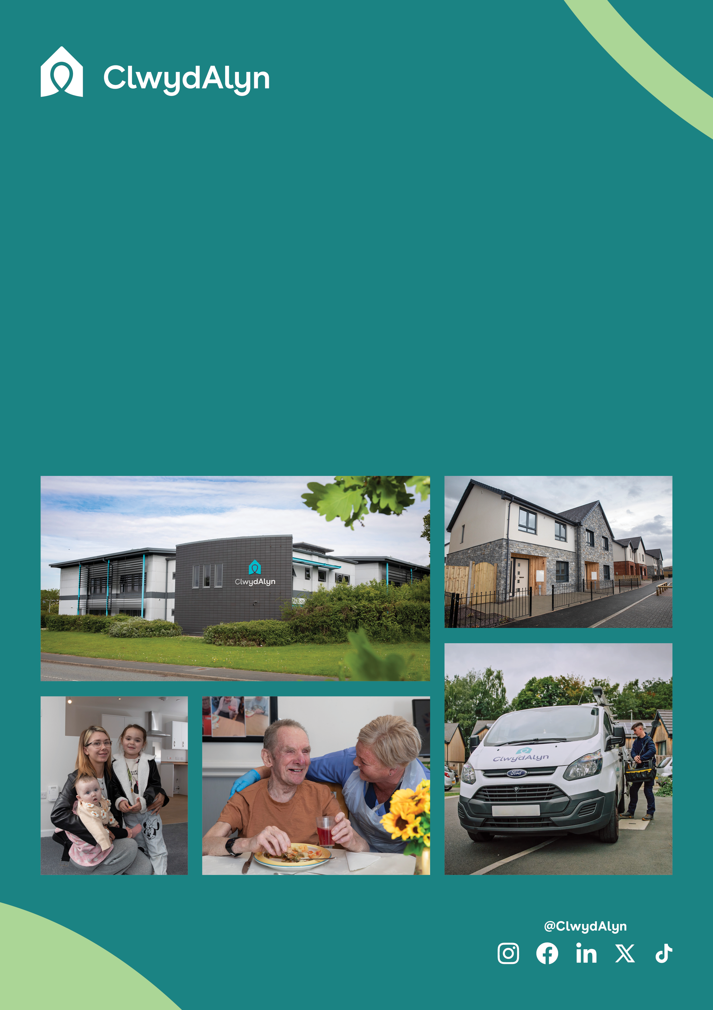

# *Job Overview*

Trainee Cook and Kitchen Assistant

# Permanent

* Pay: £11.55 per hour – NMW dependant.
* Located: Welshpool, **Neuadd Maldwyn**
* Hours: 1 vacancy @ 25 hours a week

1 vacancy @ 17 hours a week

1 vacancy @ 4 hours a week

*Department:* ***Supported Living***

# *Job Overview*

Trainee Cook and Kitchen Assistant

# 

**Is this role right for you?**

# The role of Trainee Cook and Kitchen Assistant at Neuadd Maldwyn is ideal if you have a passion for food, enjoy working as part of a team, and are eager to learn and grow in the hospitality and catering industry. To thrive in this role, you should have a basic understanding of food hygiene and be comfortable in a kitchen environment, either through prior experience or a relevant qualification.

# You will need to be reliable, hardworking, and willing to take on new challenges as you work towards your Level 2 in Hospitality and Catering. A positive attitude, attention to detail, and the ability to work well with others are essential, as you’ll be supporting a team to create enjoyable and nutritious meals for our residents. If you're motivated by making a difference and advancing your career in a supportive, friendly environment, this role could be the perfect opportunity for you.

**Department:** Resident Support Services

**Salary** **£11.55 per hour**

**Location:** Welshpool

* **Hours:** 1 vacancy @ 25 hours a week

1 vacancy @ 17 hours a week

1 vacancy @ 4 hours a week

**Job purpose:** We are seeking dedicated and passionate individuals to join our team as a Trainee Cook and Kitchen Assistant.

In this dual role, you will support food preparation, make and bake desserts, and work towards achieving a Level 2 qualification in Hospitality and Catering.

You will also assist in maintaining adequate supplies and ensuring a clean and safe working environment, contributing to the well-being and satisfaction of our residents.

**Qualifications:** This role requires an Enhanced Disclosure & Barring Service (DBS) check, which we pay for

# Key Responsibilities and Core Roles

# • Food Preparation: Assist in preparing meals and ingredients to ensure smooth kitchen operations.

# • Dessert Preparation: Support the making and baking of desserts for residents.

# • Learning and Development: Work towards achieving Level 2 in Hospitality and Catering, and a recognized management qualification.

# • Maintain Kitchen Hygiene: Help maintain a clean, safe, and hygienic kitchen environment in line with food safety standards.

# • Supply Management: Assist in maintaining adequate kitchen supplies and stock levels.

# • Support the Cook: Work closely with the cook/chef to support meal preparation and kitchen operations.

# • Health and Safety Compliance: Ensure health and safety procedures are followed, including food hygiene standards.

# • Team Collaboration: Work effectively as part of the kitchen team to deliver high-quality meals to residents. Collaboration: Work alongside residents and staff to support a clean and safe living environment.

*Job Overview*  
Trainee Cook and Kitchen Assistant

# 

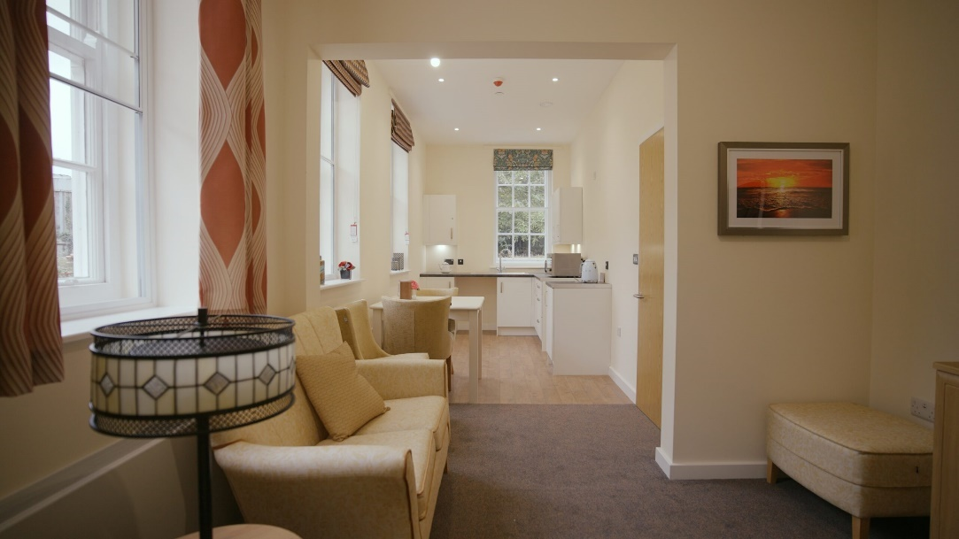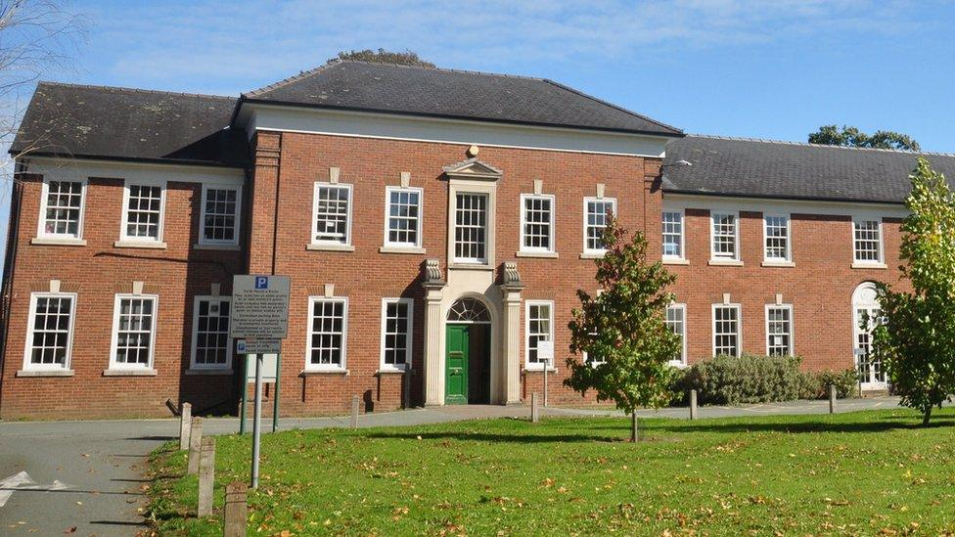\

# *Job Overview* Neuadd Maldwyn

# 

**Neuadd Maldwyn Care Home**

Neuadd Maldwyn Care Home is a newly developed facility located in the heart of Welshpool. Housed in a historic Neo-Georgian Grade II listed building, this care home has been transformed into 66 high-quality apartments for rent, designed specifically for individuals aged 60 and over who have assessed care or support needs. Our residents are older adults who require various levels of care and support.

They come from diverse backgrounds and have unique needs that we strive to meet with compassion and professionalism. The goal is to provide a comfortable, safe, and engaging environment where residents can enjoy a high quality of life. With local amenities and transport links just a short walk away, Neuadd Maldwyn is the perfect place to live and work.

As well as a free meal every day for all staff, other benefits include:

Good luck!

You can What’s app your CV, Audio note or Video by using the number 07881837177

 or email [recruitmentca@clwydalyn.co.uk](mailto:recruitmentca@clwydalyn.co.uk)

You can also apply online by visiting our website www.clwydalyn.co.uk/work-for-us

Come have a conversation with us, we look forward to hearing from you!

# How to apply?