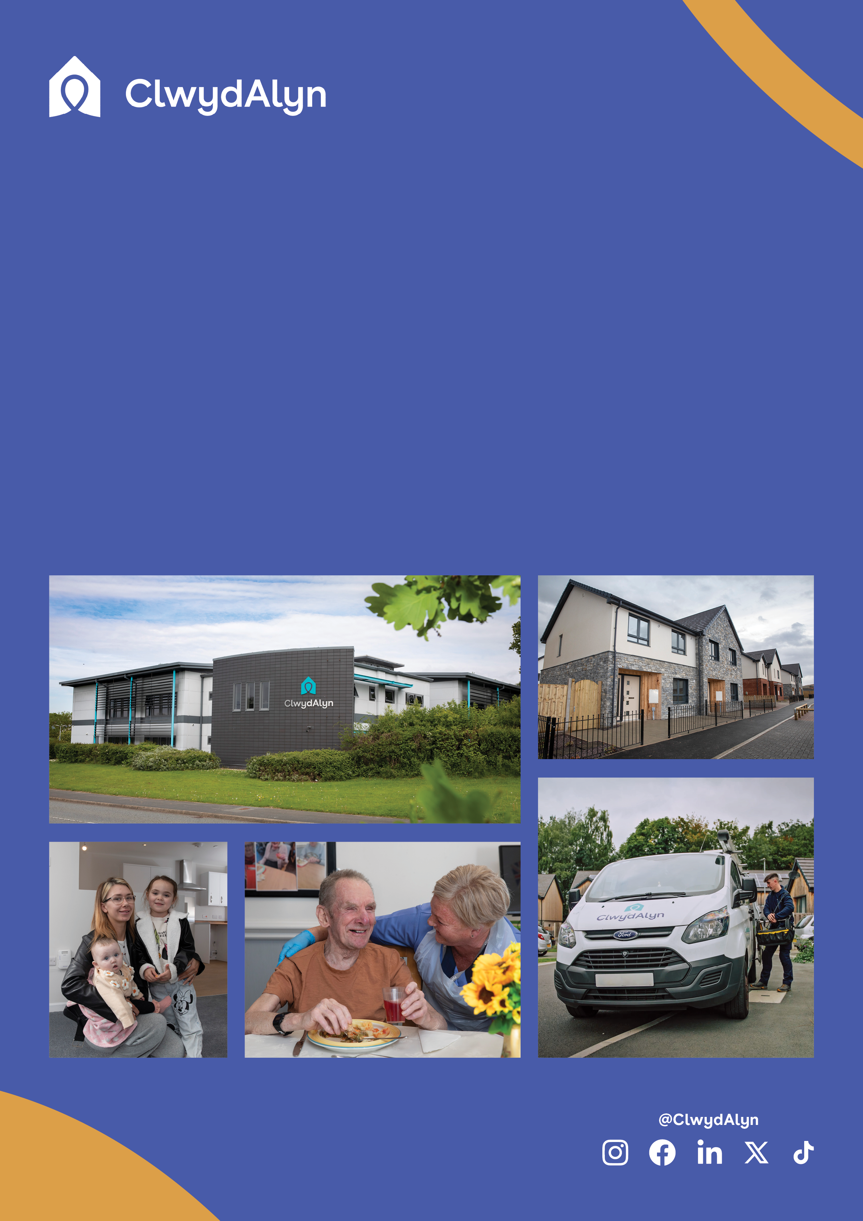

# *Job Overview*

# Cleaner

Fixed term contract until January 2026

# 

*Department: Maintenance*

* £25,056 per year
* North Wales, Field Based
* 40 hours per week
* Monday to Friday – 8am – 4.30pm

**This this role right for me?**

**To be successful as a Cleaning Operative, you should exhibit strong attention to detail and a commitment to maintaining high cleanliness standards. Excellent time management and organisational skills are essential for completing tasks within prescribed timescales and managing cleaning supplies effectively.**

**Good physical fitness is necessary for tasks involving the use of lightweight extension poles. Effective communication skills and a customer-focused attitude are crucial for interacting with residents, tenants, colleagues, and supervisors. Additionally, the ability to follow health and safety protocols and a proactive approach to training and development will ensure compliance with company procedures and legislation. If you possess these personal characteristics, this role could be a great fit for you.**

**Department:** ClwydAlyn Property Maintenance

**Salary** **£25,056 per year**

**Location** Field based, North Wales

**Duration Fixed term contract until January 2026**

**Hours** 40

**Work Pattern:** Monday – Friday 8am – 4.30pm

**Job purpose:** We are looking for someone to join our cleaning team as part of the Planned Works department. This position is primarily responsible for performing window and communal cleaning services for residential and commercial schemes, including interior and exterior cleaning of windows and communal areas to the required cleaning specification.

**Qualifications:** **This role requires an Enhanced Disclosure & Barring Service (DBS) check which we pay for.**

# *Job Overview*

# Cleaner

# 

**Apply at clwydalyn.co.uk**



# *Job Overview*

# Cleaner

# 

**Working at ClwydAlyn**

As a Cleaning Operative at ClwydAlyn, you'll use your attention to detail and organisational skills to ensure communal, commercial, and residential properties are spotless and well-maintained.

Embracing our values of trust, hope, and kindness, you'll provide excellent customer service, maintain safety and cleanliness, and work flexibly to meet community needs. Your role fosters a supportive and inclusive environment, building trust through reliable and thorough cleaning, offering hope by maintaining high living standards, and demonstrating kindness in all interactions, making a meaningful impact on residents' lives.

Key Skills and Core Functions

Your main duties will include, although not be limited to:

1. **Window Cleaning:** Use light-weight extension poles or water-fed extension poles and a water purification system for cleaning external windows.
2. **General Cleaning:** Perform cleaning tasks to support maintenance services in void, communal, commercial, and residential properties.
3. **External Area Maintenance:** Ensure external communal areas are well-maintained and free from rubbish and weeds, including removal of domestic and bulk items as necessary.
4. **Stock Management:** Assist in the efficient and effective management of cleaning supplies, making orders as needed, and maintaining a clean and fully stocked work van.
5. **Electronic Scheduling:** Follow an electronic schedule and update it upon task completion.
6. **Health and Safety Compliance:** Work in line with all health and safety requirements, company procedures, and legislation, completing any necessary training and development.

**Skills and Qualifications**

The successful candidate must have.

* The ability to maintain a high standard of cleaning to ensure a clean and safe environment
* An awareness of health and safety and alert any issues as appropriate.

• A good working knowledge of COSHH i.e., Control of Substances Hasardous to Health Regulations 1994

A full UK Driving License

As well as a free meal every day for all staff, other benefits include:

You can send a CV, Audio note or Video to the email address

[recruitmentca@clwydalyn.co.uk](mailto:recruitmentca@clwydalyn.co.uk)

You can also apply online by visiting our website www.clwydalyn.co.uk/work-for-us

Come have a conversation with us, we look forward to hearing from you!

Good luck!

