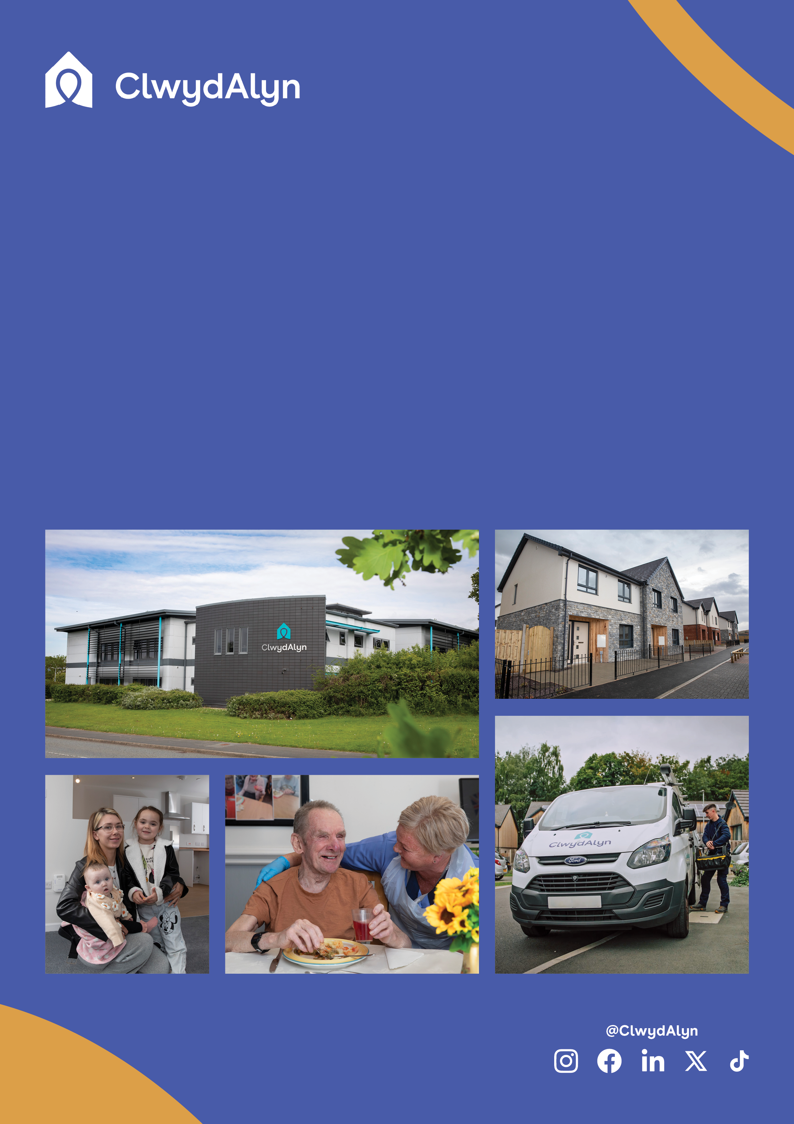

* **Job Length:** Permanent vacancy
* **Pay:** £11.42 per hour
* **Working at:** St Asaph & locations in North Wales
* **Working Hours:** 40 hours a week
* **Work Pattern:** 8.30am – 4.30pm Monday to Friday
* **Essential Requirements:** GCSE in Maths and English. Grade C or above.

# *Job Overview*

# Trainee Roofer

# 

**About ClwydAlyn and what to expect working for us as a Trainee Roofer**

ClwydAlyn Housing Association is a well-established provider of housing and support services across North Wales, dedicated to tackling poverty and improving the well-being of our communities. We are family-friendly, and a member of the Working Families Group, living our values of Trust, Kindness, and Hope every day.

As a Trainee Roofer, you will assist with the installation, repair, and maintenance of roofing systems, learning from experienced professionals while adhering to safety regulations. This role offers comprehensive training, career advancement opportunities, and a supportive work environment. We are on an exciting journey to manage over 7,500 homes by 2025 and are looking for individuals who share our commitment to making a positive impact. If you’re ready to launch a rewarding career, apply today to join our team.

**Department:** ClwydAlyn Property Maintenance

**Salary** **£11.42 an hour**

**Location:** ST Asaph, and locations around North Wales

**Hours:** 40

**Work Pattern:** Monday – Friday 8am – 4.30pm

**Job purpose:** **Join ClwydAlyn as a Trainee Roofer and you’ll earn a salary while you learn a skill & trade on the job. The programme will take around two years to complete and we welcome applications from people from all kinds of backgrounds.**

**Qualifications:**

**We need candidates to hold a GCSE in Maths and English at C grade or above.**

**This role requires an Enhanced Disclosure & Barring Service (DBS) check which we pay for.**

# *Job Overview*

# Trainee Roofer

# 

# *Job Overview*

# Trainee Roofer

# 

**Job Benefits**

# Are you looking for an excellent work life balance?

# Would you like 25 days paid holiday (increasing to 30 days), with the opportunity to sell/purchase more annual leave?

# Receive up to 8% employer pension contributions.

# Join a Cycle to Work scheme.

# Receive eye care vouchers.

# Free hot meals provided to staff when working.

* Excellent enhanced maternity package and many other company benefits.

**Who are we looking for?**

* You will be someone who can pick things up quickly and provide support to the roofing maintenance team, working from all instructions, drawings, and specifications appropriate to trade.
* Work with the ClwydAlyn Management team to establish standards and processes to ensure efficient working practices are maintained

.

* To carry out small multi skilling tasks deemed to be within the individual’s skills capacity.
* To undertake any training and development as deemed necessary and compatible with the nature of the post.
* To undertake any other duties as may be required from time to time, that are deemed necessary and compatible with the nature of the post.
* Undertake flexible working patterns from time to time as required to deliver evening / weekend appointments and cover out of hours work as required.
* To complete timesheets and submit other information relating to jobs worked upon to assist in the timely closure and valuation of the works.

**You can apply in several ways**

The more traditional approach: Send an up-to-date CV which shows your full career history and a statement explaining why you are interested in this role and the skills and experience you can bring to the role.

Send us a short film: Maximum 3 minutes explaining why you are interested in this role and the skills and experience you can bring with a short accompanying letter/email.

**Apply at clwydalyn.co.uk**

# Ffôn/Tel: 0800 1835757

# Ebost/Email: help@clwydalyn.co.uk



**Skills and Qualifications that are desirable for the role:**

* A minimum of Level 5 in (Level 2 GCSE or equivalent) Maths & English
* Good organisational skills
* Good communication skills
* Good time keeping
* Full UK driving licence.
* Share our values of Trust, Kindness and hope.

**HOW TO APPLY**

**You can apply in different ways**

**The more traditional approach**

Press the apply button on our website and upload your CV with a cover letter.

**Send your CV directly**

Send an up-to-date CV which shows your full career history and a statement explaining why you are interested in this role and the skills and experience you can bring to the role.

**Send us a short film**

Maximum 3 minutes explaining why you are interested in this role and the skills and experience you can bring.

**Audio Note**

You can send us an audio message, explaining why you are interested in this role and the skills and experience you can bring.

You can email your CV to : [recrutimentca@clwydalyn.co.uk](mailto:recrutimentca@clwydalyn.co.uk)

And you can Whats App your CV , Video or Audio note to : 07881837177

# GOOD LUCK