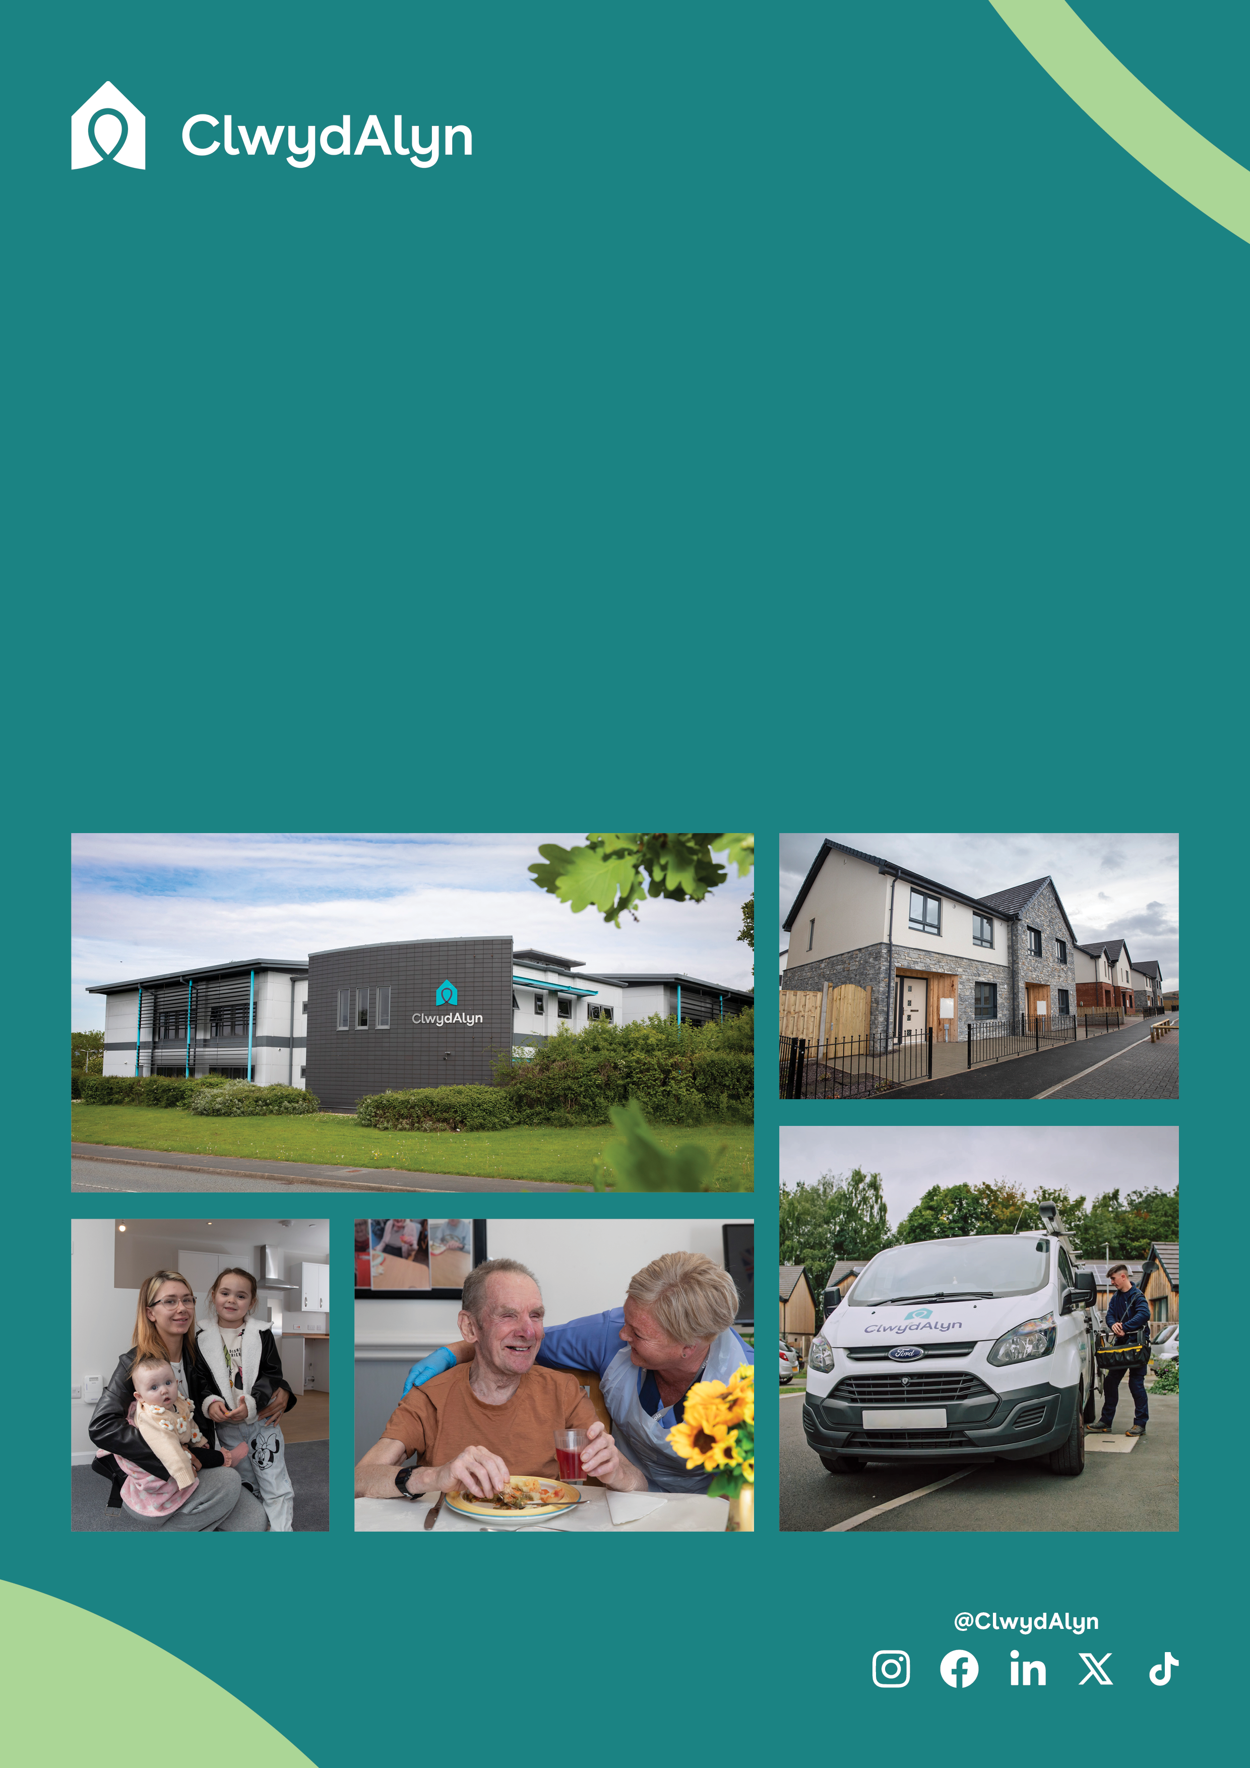

* £12.68 an hour
* Location: Holywell, Llys Emlyn Williams
* Hours: 37.5 hours
* Shifts – Rolling 9-week rota including days, nights and weekends
* Qualifications: *Youth & Community, Housing or Social*

*Care qualifications or relevant experience*

# *Job Overview*

# Project Worker

# 

*Department: Supported Living*

# Ffôn/Tel: 0800 1835757

# Ebost/Email: recrutimentca@clwydalyn.co.uk

**Department:** Supported Living

**Salary** **£12.68**

**Location:** Holywell, Llys Emlyn Williams

**Hours:** 37 .5 Hours a week

**Work Pattern:** Shift Work on a rolling 9-week rota. It will include days, weekend and night work.

**Job purpose:** As a project worker you will play an active role in creating an

environment where our residents can flourish. You will be someone who values inclusivity and is passionate about giving people support in their home and within their community to improve their quality of life.

Our mission at ClwydAlyn is “Together to Beat Poverty!” and your role is key in helping us to eradicate the causes of poverty across North Wales by enhancing the lives and promoting the wellbeing of our residents.

**Qualifications:**

Youth & Community, Housing or Social

Care qualifications or relevant experience.

**This role requires an Enhanced Disclosure & Barring Service (DBS) check which we pay for.**

# *Job Overview*

# Project Worker

# 

**Apply at clwydalyn.co.uk**

**Working at Llys Emlyn Williams / Bodyffryn & ClwydAlyn**

Llys Emlyn Williams is part of ClwydAlyn's supported living services, offering high-quality accommodation and comprehensive support for single homeless men and women aged 16-35. Located in Holywell, Flintshire, this 12-bed facility provides a safe and secure environment with shared bathroom facilities and communal spaces.

Brodyffryn has 5 rooms and is for ages 16 – 18 years old.

Working at Llys Emlyn Williams, you will be part of a dedicated team committed to empowering young individuals to transition to independent living and break free from homelessness. You will have the opportunity to provide Individual Support Plans tailored to residents' needs, and offer advice on welfare benefits, money management, and healthcare. The role also involves facilitating activities that help residents learn new life skills and get involved in the community.

The environment at ClwydAlyn is supportive and collaborative, focusing on making a positive impact on residents' lives and helping them achieve their goals and aspirations. This fulfilling role requires excellent communication skills, the ability to manage conflict, and a flexible approach to work, including the willingness to work evenings, weekends, and holidays as needed.

**Your Role:**

In this position, you will be at the forefront of shaping the future of our young residents. You will need to be adaptable, providing personalized support tailored to each individual’s needs and goals. Whether offering leadership and encouragement or being a comforting presence, your contribution will be crucial in helping residents move forward with confidence and hope.

**Our Values:** At ClwydAlyn, we uphold the values of Trust, Kindness, and Hope in everything we do. By championing these values, you will help our residents adopt the same principles, empowering them to achieve lasting positive changes in their lives.

**Why Join Us?**

* Make a meaningful difference in your community.
* Be part of a supportive and dedicated team.
* Help young individuals regain their independence and stability.
* Promote and embody values that foster trust, kindness, and hope.

If you are ready to take on this rewarding challenge and be a key influence in the lives of our residents, we would love to hear from you!

# *Job Overview*

# Project Worker

# 

# *Job Overview*

# Project Worker

# 

**As a Project Worker you will:**

* Facilitate opportunities including activities for residents which will promote social inclusion, confidence, social skills, wellbeing and diversity.
* Lead on our values incorporating safeguarding and health and safety in everything you do.
* Have a flexible and proactive approach to supporting our residents and supporting the team
* Lead by example, demonstrating our values, behaviours and Code of Conduct.
* Be accountable for your own and team actions.
* Be open and encourage honest conversations, be willing to accept and act on constructive feedback, keeping people informed, and always do what we’ve said we’ll do.
* Having a resilient approach to dealing with challenging behaviours.
* Take pride in your working environment.
* Treat everyone as an individual.
* Be open to change and work with partner agencies so that we can achieve more and find solutions to the challenges we face.
* Believe in bringing out the best in people, equipping them to make their own decisions and meeting their full potential.
* Be able to record and capture the progress of a resident’s journey
* Believe in bringing out the best in people, equipping them to make their own decisions and meeting their full potential.
* Be able to record and capture the progress of a residents
* journey.

**Key Roles and Core Functions**

Relationship building and teamwork is key to the

success of this role. You will provide advice and support

to our residents, empowering and encouraging them to

make positive choices which could lead to volunteering,

apprenticeships, work placements, education and

ultimately moving onto living an independent lifestyle and

contributing and feeling part of the community.

Your role is crucial in supporting and helping develop life

skills and the skills required to maintain a tenancy once

they move on to independent living. Skills to help support

and encourage to develop include, cooking, cleaning,

welfare benefits, access to healthcare and signposting to

specialist services such as substance misuse services and

mental health services

The role is both challenging and rewarding – making a real

difference to people’s lives means that you’ll need to me

bold, passionate and confident in having open and honest

conversations.

**Key Responsibilities:**

**Support Provision:** Provide support to residents with complex needs, including advice on welfare benefits, money management, and healthcare. Facilitate access to services like drug and alcohol advice, employment, and training opportunities.

**Resident Empowerment:** Encourage and support residents in making positive life choices, leading to opportunities such as volunteering, apprenticeships, work placements, education, and ultimately independent living.

**Social Inclusion:** Facilitate activities that promote social inclusion, confidence, social skills, wellbeing, and diversity. Help residents engage in their community and feel part of it.

**Safeguarding and Safety:** Lead on incorporating safeguarding and health and safety in all activities, ensuring a safe environment for both residents and staff.

**Relationship Building:** Build strong, trusting relationships with residents and work collaboratively with team members and external agencies to achieve the best outcomes for residents.

**Resilience and Flexibility:** Approach challenges with resilience, adapting to the changing needs of residents and the project. Handle challenging behaviours with confidence and compassion.

**Personal Accountability**: Be accountable for your actions and those of the team, demonstrating ClwydAlyn's values and code of conduct in everything you do.

**Continuous Improvement:** Be open to change, accept constructive feedback, and actively participate in finding solutions to the challenges faced by the project and its residents.

**Recording and Reporting:** Maintain accurate records of resident interactions and support plans, ensuring that all activities align with the project’s objectives and funding requirements.

**Experience and Qualities:**

**Inclusivity:** You value inclusivity and are passionate about supporting people in their homes and communities to improve their quality of life.

**Emotional Resilience:** You can manage the emotional challenges of working with individuals facing homelessness and other complex needs.

**Proactive and Flexible:** You are proactive, flexible, and committed to making a real difference in people's lives.

**Community Focused:** You believe in empowering individuals to make their own decisions and meet their full potential, helping them to integrate into and contribute to their communities.

**Job Benefits**

# 25 days paid holiday (increasing to 30 days), with the opportunity to sell/purchase more annual leave

# Receive up to 8% employer pension contributions.

# Join a Cycle to Work scheme.

# Receive eye care vouchers.

# Free hot meals provided to staff when working.

* Dedicated Wellbeing Team
* Excellent enhanced maternity package and many other company benefits

**GET IN TOUCH!**

If you have any questions or want to learn more, Helga Adams will be happy to any questions you may have. Please email [sean.mcmanus@clwydalyn.co.uk](mailto:sean.mcmanus@clwydalyn.co.uk) or whats app him at 07974367444

* **You can apply in several ways**

The more traditional approach: Send an up-to-date CV which shows your full career history and a statement explaining why you are interested in this role and the skills and experience you can bring to the role.

Send us a short film: Maximum 3 minutes explaining why you are interested in this role and the skills and experience you can bring with a short accompanying letter/email.

Send us an audio note stating the reasons you’re applying for this role. Done forget to include your name.

You can email or Whats app us. The Whats app number is 07881837177.

Good luck

**Apply at clwydalyn.co.uk**