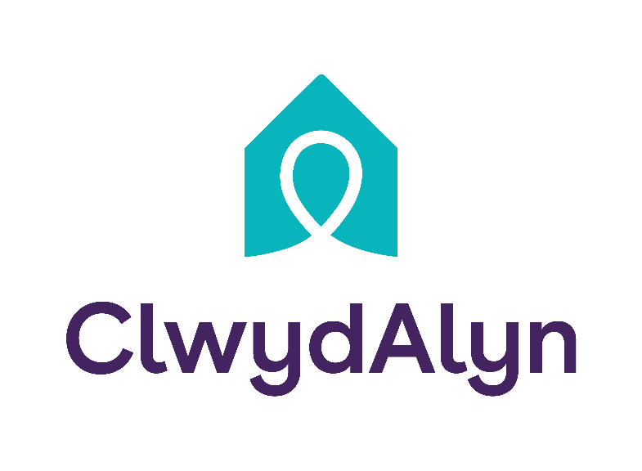
Community Development Officer

Department: Resident Services
Salary £29,175 per year
Location: ST Asaph / North Wales
Hours: 37 hour per week
Days of work: Monday to Friday
Working hours: Flexible working but generally 9am – 5pm
Occasional work outside of core hours, including weekend when needed.
Responsible for: Supporting Specialist Intervention Manager to implement initiatives such as access to healthy foods, warm homes and safer communities. Ensuring sustainable tenancies and improving quality of life and wellbeing for residents.
Qualifications: This role has been assessed as requiring a Basic Level DBS Check as staff may meet the Company’s residents or tenants. This level of check provides the Company with information regarding any unspent (current) convictions. We will pay the pay the costs for this check.
You will need a driving licence

Working at ClwydAlyn

At ClwydAlyn, our Community Development Officers play a vital role in enhancing the quality of life and wellbeing of our residents through proactive community engagement and development initiatives. Our mission to tackle poverty in Wales is guided by our core values of Trust, Hope, and Kindness. Successful candidates will need to be community-focused and demonstrate ClwydAlyn’s values. An awareness of community needs and effective collaboration with various stakeholders will be advantageous.

Key responsibilities

- To support Specialist Intervention Manager to plan, co-ordinate and deliver community development initiatives.

- Work with Specialist Intervention Manager to help communities bring about social change and improve the quality of life and wellbeing of residents in their local area.

- Ensure that appropriate file records are maintained.

- Meet with residents and members of the community to identify any unmet community needs.

- Develop activities and services to generate aspiration and confidence.

- Attend multi-agency meetings with partnership agencies.

- Identify to specialist intervention manager any areas of concern within communities and resident concerns.

- Collaborate with local authorities and partnership agencies to deliver joint community activities and initiatives.

- Gather and monitor feedback following any events / activities.

- Contribute to the effective operation of the housing and support services and the provision of a customer-orientated service.

- Liaise and work with all contacts, both internally and externally, in a friendly and helpful manner, so as to best promote the work of the Association.

- To be pro-active in developing community-based partnerships with tenants/residents and statutory/voluntary sectors.

- Develop new resources in dialogue with the community and evaluate existing programmes.

- Open communication channels to ensure residents have their say.

- Help to raise public awareness on issues relevant to the community.

- Represent ClwydAlyn at community events, meetings, and conferences.

- Assist with grant writing and fundraising activities to support community initiatives.

- Monitor project timelines, ensuring all activities are completed on schedule and within financial constraints.

- Prepare reports, presentations, and documentation for internal and external stakeholders.

Core Responsibilities

- To provide and actively promote community development for both internal and external service users and stakeholders, ensuring the customer experience is a positive one.

- To be responsible for the application of Health & Safety practices within daily working practices sharing a common responsibility for Health & Safety across the Association.

- To comply with Equality and Diversity practices in accordance with Association policy and procedures within daily operations.

- To comply with ClwydAlyn’s Policies and Procedures and to make known to your Line Manager any areas which are not adequately covered.

- A flexible approach to the role is required, which will include the requirement to work variable hours.

- To perform any other reasonable task as determined by the community development manager.

Personal Specifications:

Relationship Building:
Interpersonal Skills:
  - Exceptional interpersonal skills to establish and maintain positive relationships with community members, stakeholders, and partnership agencies.
  - Ability to engage with diverse groups, understanding their unique needs and perspectives.
Trust and Empathy:
  - Demonstrated ability to build trust within the community by showing empathy, active listening, and genuine concern for their wellbeing.
  - Proven track record of maintaining confidentiality and demonstrating integrity in all interactions.
Resilience:
Emotional Resilience:
  - Strong emotional resilience to handle challenging situations and community issues.
  - Ability to stay calm and composed under pressure, maintaining a positive attitude.
Problem-Solving:
Analytical Thinking:
  - Strong analytical skills to identify community issues and develop practical, effective solutions.
  - Ability to gather and interpret data to inform decision-making and strategy development.
Innovative Solutions:
  - Creative problem-solving skills to develop innovative community programs and initiatives.
  - Ability to think strategically and implement long-term solutions to community challenges.

  - in finding and utilizing available resources to address community needs.
Communication:
  - Excellent verbal and written communication skills, with the ability to present information clearly and effectively to diverse audiences.
  - Experience in preparing reports, presentations, and documentation for internal and external stakeholders.
- Community Focus:
  - Genuine passion for community development and improving the quality of life for residents.
- Cultural Sensitivity:
  - Understanding of and respect for cultural diversity and the needs of different communities.

