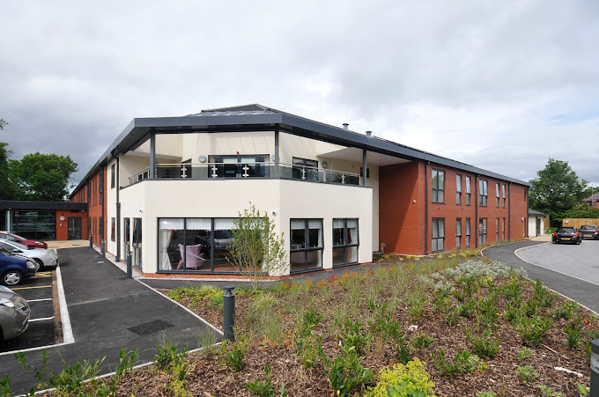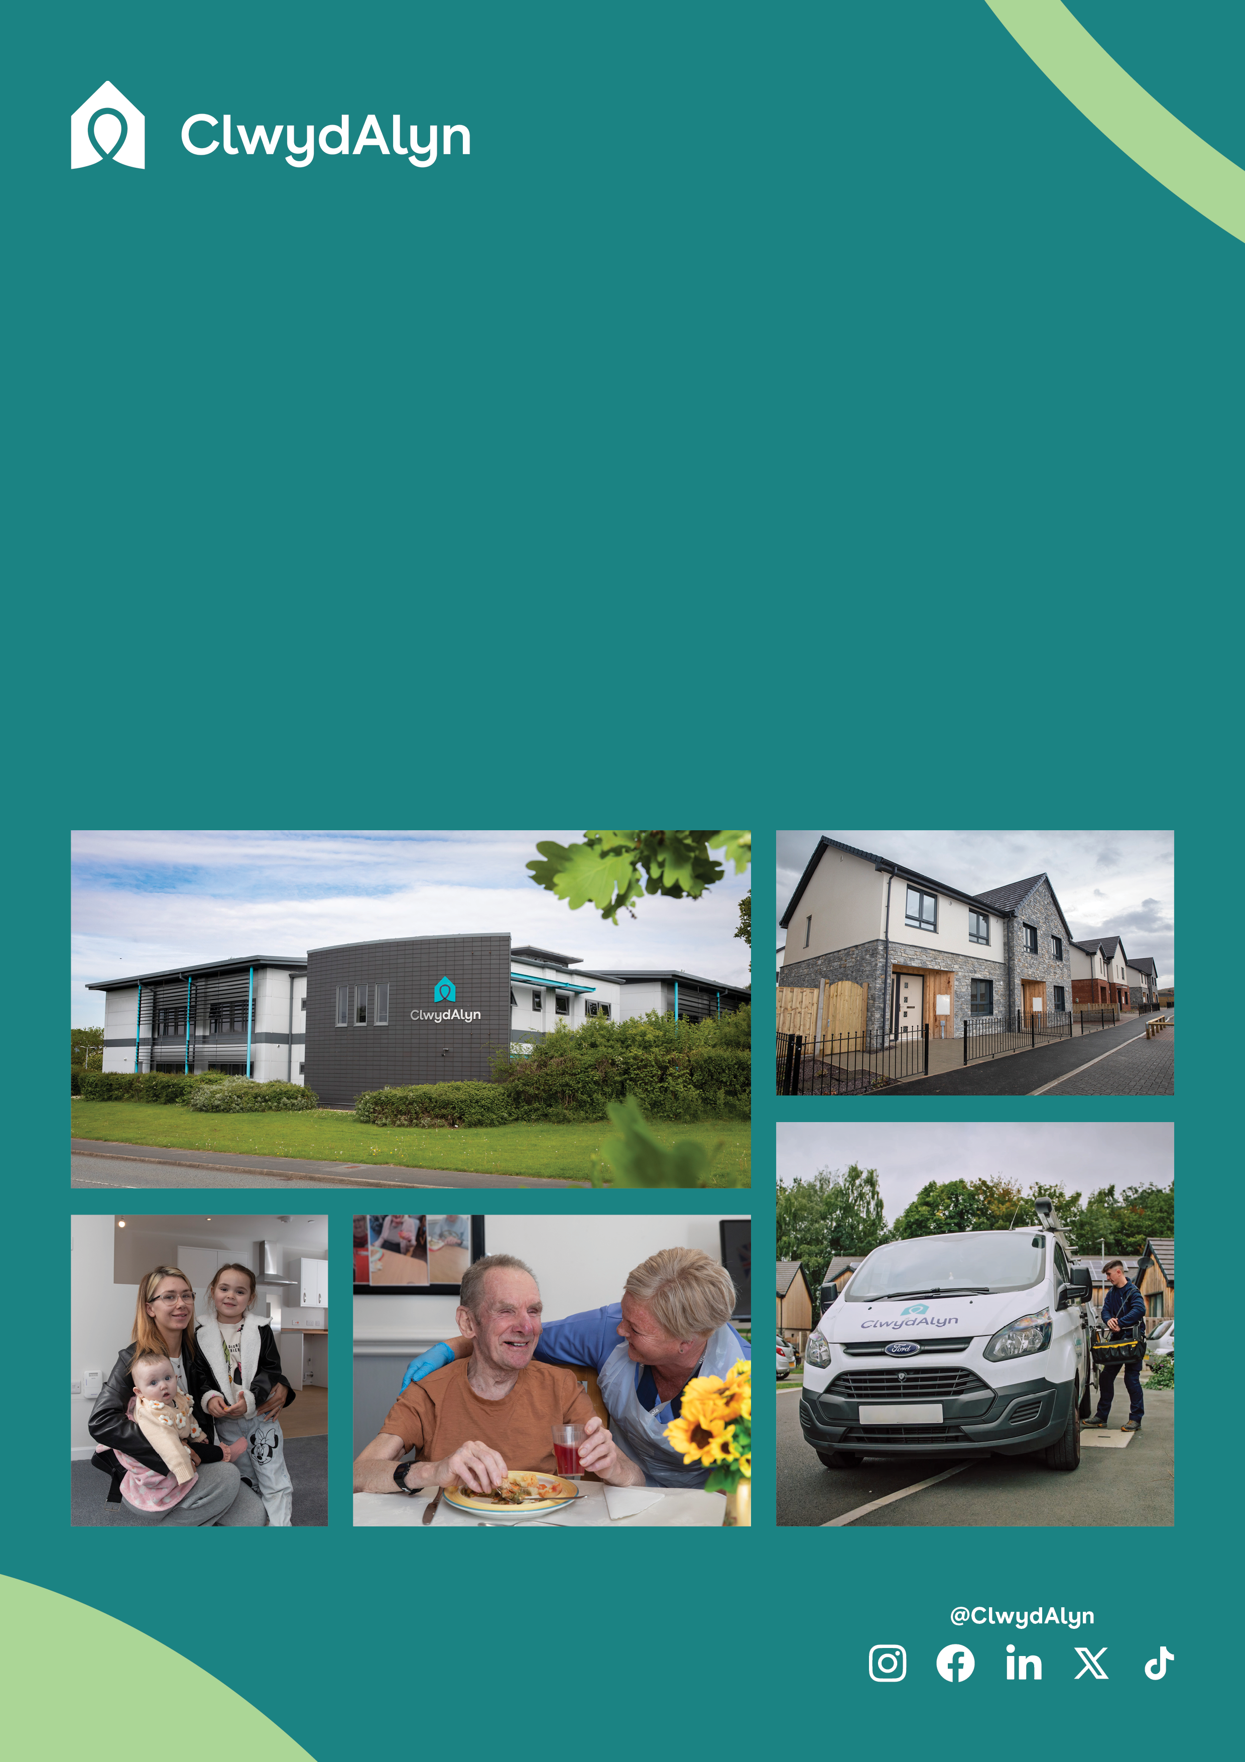 

# *Job Overview*

# Handy Person

# 

*Department*

* **Salary:** £12.00 per hour
* **Location: Chirk** Court, Chirk
* **Hours Per week:** 30 hours a week
* **Working Pattern:** Monday to Friday

**Department:** ClwydAlyn Property Maintenance

**Salary** £12 per hour

**Location:** Chirk Court, Chirk

**Hours:** 30

**Work Pattern:** Monday – Friday

**Job purpose:** To undertake day to day tasks as required by the Scheme Manager and the Senior Extra Care Manager. Ensure good working relationships are maintained with staff employed at the scheme, liaising with families, ClwydAlyn staff and contractors who visit the scheme.

**Qualifications:**

No formal qualifications are required for the role although a knowledge of any of the building trades would be desirable as would an appreciation of the legal requirements under the legislation i.e. Health & Safety & COSHH etc as it relates to this role.

**This role requires an Enhanced Disclosure & Barring Service (DBS) check which we pay for.**

**Key responsibilities**

* General Maintenance: Conduct minor repairs and maintenance tasks within the scheme, including fixing door handles, windows, and changing light bulbs. Ensure any major repair needs are reported to the Scheme Manager promptly.
* Health and Safety Compliance: Perform regular health and safety checks and related risk assessments as requested. This includes Legionella checks, temperature checks, and fire safety inspections to ensure a safe living environment.
* Grounds and Communal Areas: Assist in maintaining the external grounds and communal areas of the property. Ensure these areas are tidy, free from rubbish and weeds, and that all signage is visible and maintained.

# *Job Overview*

# Handy Person

# 

**Key responsibilities**

* Waste Management: Oversee the control of rubbish and used consumables, ensuring proper disposal and sanitation in line with COSHH regulations.
* Support Services: Provide assistance to the Scheme Manager and residents, including managing deliveries, mail distribution, and periodic audits of furniture and fittings. Support cleaning services and ensure guest accommodations are well-maintained.
* Customer Service: Deliver excellent customer service, actively promoting a positive and supportive environment for residents, staff, and visitors.
* Record Keeping: Maintain comprehensive logs of tasks performed, associated costs, and ensure all cleaning materials are stored correctly with proper stock control.

**Working at ClwydAlyn**

At ClwydAlyn, we put people at the heart of our business. We are committed to our values of trust, kindness, and hope as we implement our new business plan focused on tackling poverty across North Wales. We strive to create a supportive and inclusive workplace where every team member can thrive. Our benefits include 25 days of annual leave (increasing to 30 days), life assurance, matched pension contributions, an Employee Assistance Program (EAP), and various voluntary benefits.

Join our team and be part of an organisation dedicated to providing excellent care and support to our residents while fostering a collaborative and compassionate work environment.

# *Job Overview*

# Handy Person

# 

**Job Benefits**

# Are you looking for an excellent work life balance?

# Would you like 25 days paid holiday (increasing to 30 days), with the opportunity to sell/purchase more annual leave?

# Receive up to 8% employer pension contributions.

# Join a Cycle to Work scheme.

# Receive eye care vouchers.

# Free hot meals provided to staff when working.

* Excellent enhanced maternity package and many other company benefits.

**You can apply in several ways**

The more traditional approach: Send an up-to-date CV which shows your full career history and a statement explaining why you are interested in this role and the skills and experience you can bring to the role.

Send us a short film: Maximum 3 minutes explaining why you are interested in this role and the skills and experience you can bring with a short accompanying letter/email.

# Ffôn/Tel: 0800 1835757

# Ebost/Email: help@clwydalyn.co.uk

**Apply at clwydalyn.co.uk**

**Apply at clwydalyn.co.uk**