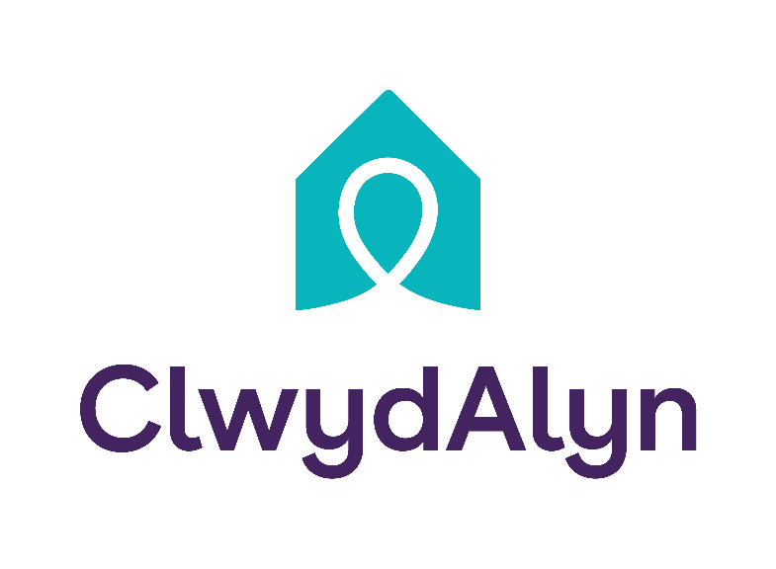
Job Overview
Senior Day Care Practitioner
2 Vacancies

Department: Resident Services
Salary £13.19 + 60 pence per hour for night work as an additional payment.
Location: Chrik, Chirk Court
Hours: BANK
Job purpose: As a Senior Night Care Practitioner at Chirk Court, you will play a vital role in providing compassionate, high-quality care to residents, particularly those living with dementia. You will be working in a small household of 10 residents supporting with personal care and administering of medication. you will have the support of the other seniors in the other household action to Department.
Your primary responsibilities will include leading and supporting a dedicated team of care staff, ensuring that care delivery meets the highest standards, and managing the staffing rota to meet the diverse needs of our residents.
Your leadership will help ensure that Chirk Court continues to be a safe, supportive, and nurturing environment for all residents, in line with ClwydAlyn Housing’s values of Trust, Kindness, and Hope.

Requirements: You must have one of the following qualifications:
NVQ Level 2 in Health and Social Care,
Diploma Level 2 or Core qualification and willing to work towards Level 3 Health and Social Care

Working at Chirk Court

Working at Chirk Court in Wrexham offers a rewarding experience for those dedicated to providing high-quality care, particularly for residents with dementia. The care home, part of ClwydAlyn Housing, emphasises Trust, Kindness, and Hope, creating a supportive and collaborative work environment. Staff are expected to deliver compassionate care while managing tasks like care planning and rota management. The role is demanding but fulfilling, with benefits including holiday allowances, pension contributions, and perks like free meals. Chirk Court is a place where employees feel valued and can make a meaningful difference in residents' lives.

Key responsibilities
Lead and Support Care Staff: Oversee and mentor the care team, ensuring that all staff members deliver high-quality care in line with established standards.
Care Delivery and Planning: Manage and implement care plans using IT systems, ensuring they are tailored to meet the individual needs of residents, particularly those with dementia.
Staff Rota Management: Organise and manage the staffing rota to ensure adequate coverage at all times, meeting the care needs of residents.
Resident Care: Provide direct care, demonstrating a deep understanding of the physical, social, and psychological needs of residents.
Compliance and Training: Ensure compliance with all relevant regulations and oversee the completion of required training, such as the All Wales Induction Framework.
Communication and Reporting: Maintain clear communication with residents, families, and healthcare professionals, and ensure accurate documentation of care activities.
Personal Specifications:
Lead and Support Care Staff: Oversee and mentor the care team, ensuring that all staff members deliver high-quality care in line with established standards.

Care Delivery and Planning: Manage and implement care plans using IT systems, ensuring they are tailored to meet the individual needs of residents, particularly those with dementia.

Staff Rota Management: Organize and manage the staffing rota to ensure adequate coverage at all times, meeting the care needs of residents.

Resident Care: Provide direct care, demonstrating a deep understanding of the physical, social, and psychological needs of residents.
Compliance and Training: Ensure compliance with all relevant regulations and oversee the completion of required training, such as the All Wales Induction Framework.

Communication and Reporting: Maintain clear communication with residents, families, and healthcare professionals, and ensure accurate documentation of care activities.
You will be part of a supportive and dedicated team that values professional development and encourages skill growth. Join us to contribute to our mission, work within a positive environment, and help improve the lives of those we serve.

