REQUEST FOR EXECUTIVE TEAM APPROVAL

SCHEDULE 1 TO THE 1996 HOUSING ACT

- In accordance with the requirements of Permitted Payments and Benefits, Paragraph 2 of Schedule 1 to the Housing Act, formerly Section 15 Housing Act 1988, approval is sought to approve the employment of employees who are related.

- The Association advertised for a Customer Service Advisor and Emma Lester, Wife and Aunty and Friend of Gary Lester (Husband), Megan Blackwell (Niece) and Nigel Blackwell (Friend), applied for the post and in accordance with the recruitment and selection procedure was short listed. The interview and selection process were undertaken by Melody Blackwell-Jones and Kirsty Welch who concluded that they wished to offer the post to Emma Lester. Gary Lester, Megan Blackwell and Nigel Blackwell of V72 was in no way connected to the interviewing process.

- Schedule 1 of the Housing Act 1996 forbids the employment of persons who are closely related to existing employees. Housing for Wales, in the exercise of its powers under Schedule 1 of the Housing Act 1996, made a determination in 1996 giving specific exemptions in certain cases. Exemption 1 permits the employment of a person who is the close relative of a person employed by the Association. In order to apply these exemptions, the Association must advertise the posts openly in accordance with normal principles of equal opportunities and the decision to appoint must be approved by the Executive Team.

- In this case the Association has openly advertised the vacant post internally and externally. There were 45 applicants for the post of Customer Service Advisor, 3 were successful including Emma Lester who was successful in respect of the post also.

- Delegated authority is, therefore, requested to enable the granting of a contract of employment to Emma Lester, in accordance with the exemptions stated above. If approved, this will be entered on the special register which exists in respect of such cases of exemption.

Signed: 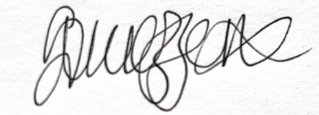
Suzanne Mazzone
Executive Director Housing Service

Date: 26th of July 2024

