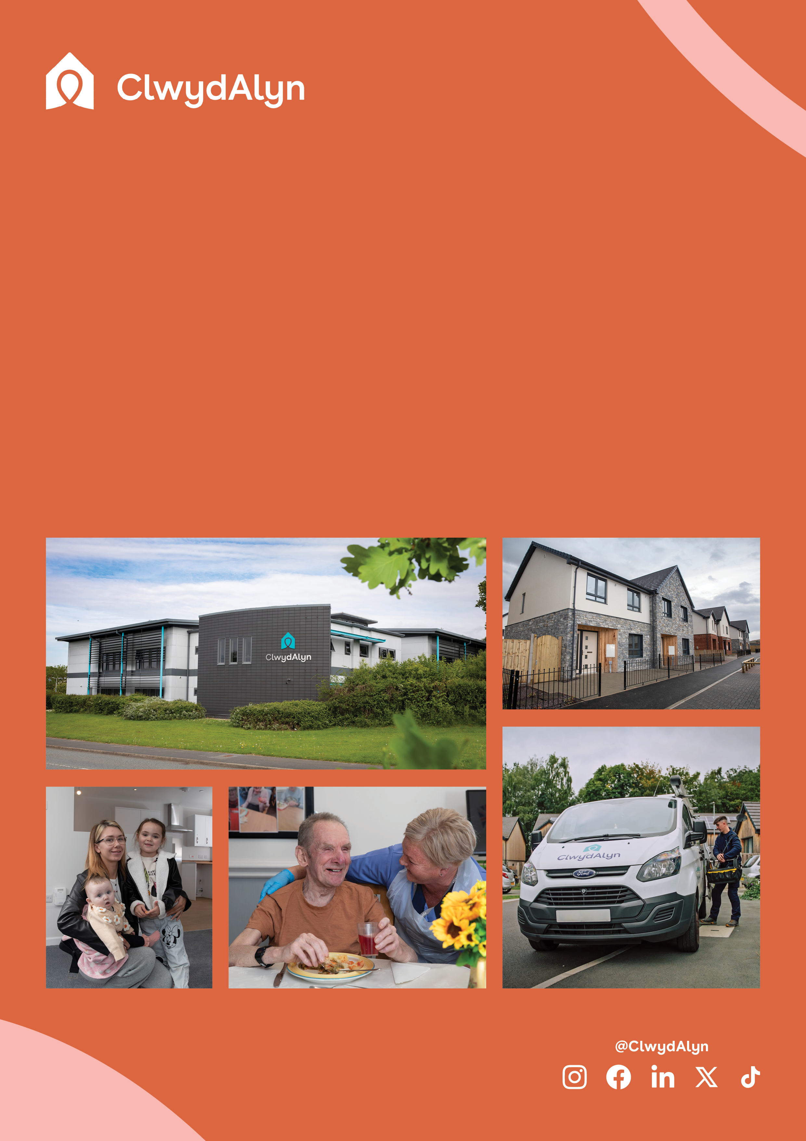

* Salary: £48,978 per annum
* V72, St Asaph – Hybrid Working
* 37 hours a week
* Monday to Friday – Flexible working pattern
* Qualifications: Relevant degree or industry experience

# *Job Overview*

# Business Performance and Insights Manager

# 

*Department*

# *Job Overview*

# Business Performance and Insights Manager

# 

**Department:** ClwydAlyn Business Intelligence

**Salary** **£48,978 per annum**

**Location:** St Asaph & Hybrid Working

**Hours:** 37 hours a week – With a flexible working pattern

**Work Pattern:** Monday – Friday

**Job purpose:** We are seeking a highly skilled Business Performance and Insights Manager to lead on data management, reporting, and insights generation

At ClwydAlyn, data is at the very core of how we achieve our mission of "together to beat poverty." It is not just a by-product of our operations; it is the key to ensuring that everyone in North Wales has access to quality housing, affordable food, a warm home, and a thriving community.

This new role will help ensure that insight is at the heart of our decision making by providing central oversight of critical datasets, implementing data governance, and standardising reporting practices. You will champion a data-driven culture, advocating for best practices in data governance and reporting standards.

The successful candidate will work closely with Senior and Executive Leadership Teams to ensure data consistency, accuracy as well as to support and enable strategic decision-making.

**Qualifications:** Relevant degree or industry experience

**Apply at clwydalyn.co.uk**

# *Job Overview*

# Business Performance and Insights Manager

# 

Working at ClwydAlyn

At ClwydAlyn, you will find a positively friendly and inclusive environment where every team member is valued and supported. We are committed to fostering a workplace culture that encourages growth, collaboration, and mutual respect. As a Business Performance and Insights Manager, you will be part of a dynamic team that values your contributions and supports your professional development.

Our dedicated Learning and Development team is here to ensure you have access to ongoing training and career advancement opportunities. Whether it's through workshops, courses, or mentorship programs, we are invested in your continuous learning and success.

In addition to a supportive work environment, ClwydAlyn offers a comprehensive benefits package designed to enhance your well-being and financial security. This includes up to 8% pension contributions, ensuring your future is well taken care of.

Joining ClwydAlyn means being part of a company with a profound social purpose. Our mission, "together to beat poverty," drives everything we do. By leveraging your skills and expertise in data management and insights generation, you will contribute directly to initiatives that improve the quality of housing, ensure affordable food, provide warm homes, and build thriving communities across North Wales.

Be part of a team where your work has a tangible impact on people's lives, and where you are supported and valued every step of the way. At ClwydAlyn, we believe in the power of community, and together, we can make a real difference.

Why work for us – Benefits

As well as making sure staff have access to a free meal each day, other benefits include:

**Key Responsibilities:**

**Performance Analysis and Insight**

· Oversee all aspects of performance management, from developing indicators and reports to delivering insightful and timely analyses that support strategic and operational decisions.

· Pioneer innovative methods, including advanced and predictive analytics, to enable senior leaders to leverage data for shaping services across ClwydAlyn.

**Data**

· Implement and uphold data assurance practises, ensuring high standards of data quality and accuracy for sound decision-making.

· Administer data infrastructure and business intelligence systems to support efficient performance analysis and insights.

**Collaboration**

· Serve as a bridge between performance analysis and other teams, advocating for data-driven insights across the organisation.

· Build strong working relationships and influence colleagues to make data-informed decisions that drive improvements at all levels.

· Work closely with team members to keep data reporting aligned with current and future business needs, highlighting insights and communicating their impact to stakeholders.

**External**

· Oversee the collation and validation of external data and ensure regulatory reporting meets the highest standards.

· Lead benchmarking efforts to challenge and improve performance, identifying best practices and driving efficiencies and value.

Leadership

· Work with the Head of Business Intelligence to advance the organisation’s data strategy.

· Act as the ClwydAlyn’s go-to reporting expert, promoting excellence in analytics and closing skill gaps within the team.

· Guide and mentor the Reporting Analyst, fostering growth and enhancing reporting standards and practices across the team.

**Key Skills**

Essential:

· Advanced analytical skills (e.g., SQL, Excel, Power BI, SSRS, power query) to interpret data and influence decision-making.

· Ability to translate data and information into meaningful narratives and actionable recommendations.

· Proficiency in understanding customer and business needs, translating complex data for decision support.

· Skilled in proactive and collaborative engagement with stakeholders to develop data solutions and enhance systems.

· Ability to identify areas of opportunity, define the reporting and analytical requirements and articulate the steps needed to improve performance and delivery

· Experienced in building analytical and performance frameworks to support continuous service improvement.

· Proven ability to engage with colleagues at all organisational levels.

**Desirable:**

· Familiarity with statistical software (e.g., R, Stata, SAS, Matlab) and programming languages (e.g., Python).

· Experience in partnering with external stakeholders to drive shared goals.

You can What’s app your CV, Audio note or Video by using the number 07881837177

or email your CV to [recruitmentca@clwydalyn.co.uk](mailto:recruitmentca@clwydalyn.co.uk)

or visit our website [www.clwydalyn.co.uk/work-for-us](http://www.clwydalyn.co.uk/work-for-us)

Come have a conversation with us, we look forward to hearing from you!

GOOD LUCK